**Ulaş Cem Erten**

**2256006**

**CNG 336 – LAB2 PREWORK**

**2.2.3)**

i.

Pseudo-code)

Define_necessary_library

Declare_lcd_ports

Initilaze_stack

Initilaze_ports

Number_A <- PINA

Number_B <- PIND

Control_Input <- PINE

IF Control_Input == 00

Odd_Parity()

ClearLCD_SecondLine()//This is always for not seen anything in second line when input is 00

Display_LCD_FirstLine()

Else If Control_Input == 01

Even_Parity()

ClearLCD_SecondLine()//This is always for not seen anything in second line when input is 01

Display_LCD_FirstLine()

Else If Control_Input == 10

Show_Bigger()

ClearLCD_FirstLine()//This is always for not seen anything in firstline when input is 10

Display_LCD_second_Line_in_Hex()

Else

Show_Difference()

Display_LCD_FirstLine()

Display_LCD_second_Line_in_Hex()

Odd_Parity(){

C=Find_Number_Of_Ones(R22)

IF C%2 == 0

Shift_Left(R22)

C = C + 1

Else

Shift_Left(R22)

Return

}

Even_Parity(){

C=Find_Number_Of_Ones(R22)

IF C%2 == 1

Shift_Left(R22)

C = C + 1

Else

Shift_Left(R22)

Return

}

Show_Bigger(){

If A > B

Display(A)

Else if B > A

Display(B)

Else

Display(‘EQ’)

}

Show_Diff(){

If A>B

R22 = A - B

Else if B > A

R22 = B – A

Else

R22 = 0

Return

}

ClearLCD_SecondLine(){

Display(Space)

Display(Space)

}

ClearLCD_FirstLine(){

For(I=0;I<9;I++){

Display(Space)

}

Display_LCD_FirstLine(){

For(i = 0 ;i < 8 ; i ++){

Rotate_With_Carry(R17)

If(c==1)

Display(1)

Else

Display(0)

}

Return

}

Display_LCD_SecondLine(){

Text_in_Hex <- Convert_To_Hex(R22)

Display(Test_in_Hex)

Return

}

ii.

.INCLUDE "m128def.inc"

.equ fclk = 8000000 ; system clock frequency (for delays)

; register usage

.def temp = R16 ; temporary storage

; LCD interface

.equ lcd_D7_port = PORTC ; lcd D7 connection

.equ lcd_D7_bit = PORTC7

.equ lcd_D7_ddr = DDRC

.equ lcd_D6_port = PORTC ; lcd D6 connection

.equ lcd_D6_bit = PORTC6

.equ lcd_D6_ddr = DDRC

.equ lcd_D5_port = PORTC ; lcd D5 connection

.equ lcd_D5_bit = PORTC5

.equ lcd_D5_ddr = DDRC

.equ lcd_D4_port = PORTC ; lcd D4 connection

.equ lcd_D4_bit = PORTC4

.equ lcd_D4_ddr = DDRC

.equ lcd_E_port = PORTB ; lcd Enable pin

.equ lcd_E_bit = PORTB5

.equ lcd_E_ddr = DDRB

.equ lcd_RS_port = PORTB ; lcd Register Select pin

.equ lcd_RS_bit = PORTB2

.equ lcd_RS_ddr = DDRB

.equ text=0xaa00

.equ text1=0x0200

.equ ZEROS = 0x00

.equ ONES = 0xff

.equ any = 0x500

.equ any1 = 0x501

.equ any2 = 0x502

; LCD module Lines

.equ lcd_LineOne = 0x00 ; line 1

.equ lcd_LineTwo = 0x40 ; line 2

; LCD Defined instructions

.equ lcd_Clear = 0b00000001 ; ASCII 'space' for all characters

.equ lcd_Home = 0b00000010 ; first position on first line

.equ lcd_EntryMode = 0b00000110 ; shift cursor from left to right on read/write

.equ lcd_DisplayOff = 0b00001000 ; turn display off

.equ lcd_DisplayOn = 0b00001100 ; display on, cursor off, don't blink character

.equ lcd_FunctionReset = 0b00110000 ; reset the LCD

.equ lcd_FunctionSet4bit = 0b00101000 ; 4-bit data, 2-line display, 5 x 7 font

.equ lcd_SetCursor = 0b10000000 ; set cursor position

; **************************** Reset Vector *****************************

.org 0x0000

jmp start ; jump over Interrupt Vectors, Program ID etc.

; **************************** Main Program Code ************************

start:

; initialize the stack pointer to the highest RAM address

ldi temp,low(RAMEND)

out SPL,temp

ldi temp,high(RAMEND)

out SPH,temp

ldi r20, ZEROS

ldi r21, ONES

; configure the microprocessor pins for the control lines

sbi lcd_E_ddr, lcd_E_bit ; E line - output

sbi lcd_RS_ddr, lcd_RS_bit ; RS line - output

; initialize the LCD controller

ldi r16, 0x00 ; Load 0 to R16

out ddra, r16 ; Configure PORTA as input

call lcd_init_4d ; initialize the LCD display for a 4-bit interface

; configure the microprocessor pins for the data lines

sbi lcd_D7_ddr, lcd_D7_bit ; 4 data lines - output

sbi lcd_D6_ddr, lcd_D6_bit

sbi lcd_D5_ddr, lcd_D5_bit

sbi lcd_D4_ddr, lcd_D4_bit

HERE:out ddra, r20;a is input

out ddrd, r20;d is input

out ddre, r20;e is input

out ddrb, r21; b is output

out ddrc, r21; c is output

in r22,pina ;put the value in pina into r22

in r23,pind;put the value in pind into r23

in R24,pine;put the value in pine into r24

cpi R24, 0x00 ; check if the value entered from pine is 0

breq call_odd_parity ; go to label

cpi R24, 0x01; check if the value entered from pine is 1

breq call_even_parity; go to label

cpi R24, 0x02; check if the value entered from pine is 2

breq call_show_bigger;go to label

cpi R24, 0x03; check if the value entered from pine is 3

breq call_show_diff; go to label

call_odd_parity:

call display_empty_LineTwo;to be second line of lcd always empty

call odd_parity;call odd parity function

jmp HERE ; jump back to here

call_even_parity:

call display_empty_LineTwo;to be second line of lcd always empty

call even_parity;call even parity function

jmp HERE ; jump back to here

call_show_bigger:

call show_bigger;call odd parity function

call display_empty_LineOne;to be first line of lcd always empty

call display2 ; call display in hexadecimal function

jmp HERE ; jump back to here

call_show_diff:

call show_diff;call odd parity function

call display1;call display in binary function

call display2;call display in hexadecimal function

jmp HERE ; jump back to here

; endless loop

rjmp HERE

; **************************** End of Main Program Code *****************

; ============================== 4-bit LCD Function Calls ======================

; Name: lcd_init_4d -- initialize the LCD module for a 4-bit data interface

lcd_init_4d:

; Power-up delay

ldi temp, 100 ; initial 40 mSec delay

call delayTx1mS

; IMPORTANT - At this point the LCD module is in the 8-bit mode and it is expecting to receive

; 8 bits of data, one bit on each of its 8 data lines, each time the 'E' line is pulsed.

;

; Since the LCD module is wired for the 4-bit mode, only the upper four data lines areconnected to

; the microprocessor and the lower four data lines are typically left open. Therefore, when

; the 'E' line is pulsed, the LCD controller will read whatever data has been set up on theupper

; four data lines and the lower four data lines will be high (due to internal pull-upcircuitry).

;

; Fortunately the 'FunctionReset' instruction does not care about what is on the lower fourbits so

; this instruction can be sent on just the four available data lines and it will beinterpreted

; properly by the LCD controller. The 'lcd_write_4' subroutine will accomplish this if the

; control lines have previously been configured properly.

; Set up the RS and E lines for the 'lcd_write_4' subroutine.

cbi lcd_RS_port, lcd_RS_bit ; select the Instruction Register (RS low)

cbi lcd_E_port, lcd_E_bit ; make sure E is initially low

; Reset the LCD controller.

ldi temp, lcd_FunctionReset ; first part of reset sequence

call lcd_write_4

ldi temp, 10 ; 4.1 mS delay (min)

call delayTx1mS

ldi temp, lcd_FunctionReset ; second part of reset sequence

call lcd_write_4

ldi temp, 200 ; 100 uS delay (min)

call delayTx1uS

ldi temp, lcd_FunctionReset ; third part of reset sequence

call lcd_write_4

ldi temp, 200 ; this delay is omitted in the data sheet

call delayTx1uS

; Preliminary Function Set instruction - used only to set the 4-bit mode.

; The number of lines or the font cannot be set at this time since the controller is still inthe

; 8-bit mode, but the data transfer mode can be changed since this parameter is determined byone

; of the upper four bits of the instruction.

ldi temp, lcd_FunctionSet4bit ; set 4-bit mode

call lcd_write_4

ldi temp, 80 ; 40 uS delay (min)

call delayTx1uS

; Function Set instruction

ldi temp, lcd_FunctionSet4bit ; set mode, lines, and font

call lcd_write_instruction_4d

ldi temp, 80 ; 40 uS delay (min)

call delayTx1uS

; The next three instructions are specified in the data sheet as part of the initialization routine,

; so it is a good idea (but probably not necessary) to do them just as specified and then redo them

; later if the application requires a different configuration.

; Display On/Off Control instruction

ldi temp, lcd_DisplayOff ; turn display OFF

call lcd_write_instruction_4d

ldi temp, 80 ; 40 uS delay (min)

call delayTx1uS

; Clear Display instruction

ldi temp, lcd_Clear ; clear display RAM

call lcd_write_instruction_4d

ldi temp, 4 ; 1.64 mS delay (min)

call delayTx1mS

; Entry Mode Set instruction

ldi temp, lcd_EntryMode ; set desired shift characteristics

call lcd_write_instruction_4d

ldi temp, 80 ; 40 uS delay (min)

call delayTx1uS

; This is the end of the LCD controller initialization as specified in the data sheet, but the display

; has been left in the OFF condition. This is a good time to turn the display back ON.

; Display On/Off Control instruction

ldi temp, lcd_DisplayOn ; turn the display ON

call lcd_write_instruction_4d

ldi temp, 80 ; 40 uS delay (min)

call delayTx1uS

ret

; ---------------------------------------------------------------------------

; Name: lcd_write_string_4d

; Purpose: display a string of characters on the LCD

; Entry: ZH and ZL pointing to the start of the string

; (temp) contains the desired DDRAM address at which to start the display

; Exit: no parameters

; Notes: the string must end with a null (0)

; uses time delays instead of checking the busy flag

lcd_write_string_4d:

; preserve registers

push ZH ; preserve pointer registers

push ZL

; fix up the pointers for use with the 'lpm' instruction

;lsl ZL ; shift the pointer one bit left for the lpm instruction

;rol ZH

; set up the initial DDRAM address

ori temp, lcd_SetCursor ; convert the plain address to a set cursor instruction

call lcd_write_instruction_4d ; set up the first DDRAM address

ldi temp, 80 ; 40 uS delay (min)

call delayTx1uS

; write the string of characters

lcd_write_string_4d_01:

ld temp, Z+ ; get a character

cpi temp, 0 ; check for end of string

breq lcd_write_string_4d_02 ; done

; arrive here if this is a valid character

call lcd_write_character_4d ; display the character

ldi temp, 80 ; 40 uS delay (min)

call delayTx1uS

rjmp lcd_write_string_4d_01 ; not done, send another character

; arrive here when all characters in the message have been sent to the LCD module

lcd_write_string_4d_02:

pop ZL ; restore pointer registers

pop ZH

ret

; ---------------------------------------------------------------------------

; Name: lcd_write_character_4d

; Purpose: send a byte of information to the LCD data register

; Entry: (temp) contains the data byte

; Exit: no parameters

; Notes: does not deal with RW (busy flag is not implemented)

lcd_write_character_4d:

sbi lcd_RS_port, lcd_RS_bit ; select the Data Register (RS high)

cbi lcd_E_port, lcd_E_bit ; make sure E is initially low

call lcd_write_4 ; write the upper 4-bits of the data

swap temp ; swap high and low nibbles

call lcd_write_4 ; write the lower 4-bits of the data

ret

; ---------------------------------------------------------------------------

; Name: lcd_write_instruction_4d -- Send a byte of information to the LCD instruction register

lcd_write_instruction_4d:

cbi lcd_RS_port, lcd_RS_bit ; select the Instruction Register (RS low)

cbi lcd_E_port, lcd_E_bit ; make sure E is initially low

call lcd_write_4 ; write the upper 4-bits of the instruction

swap temp ; swap high and low nibbles

call lcd_write_4 ; write the lower 4-bits of the instruction

ret

; ---------------------------------------------------------------------------

; Name: lcd_write_4 Send 4-bits of information to the LCD module

; Entry: (temp) contains a byte of data with the desired 4-bits in the upper nibble

; (RS) is configured for the desired LCD register

; (E) is low

; (RW) is low

lcd_write_4:

; set up D7

sbi lcd_D7_port, lcd_D7_bit ; assume that the D7 data is '1'

sbrs temp, 7 ; check the actual data value

cbi lcd_D7_port, lcd_D7_bit ; arrive here only if the data was actually '0'

; set up D6

sbi lcd_D6_port, lcd_D6_bit ; repeat for each data bit

sbrs temp, 6

cbi lcd_D6_port, lcd_D6_bit

; set up D5

sbi lcd_D5_port, lcd_D5_bit

sbrs temp, 5

cbi lcd_D5_port, lcd_D5_bit

; set up D4

sbi lcd_D4_port, lcd_D4_bit

sbrs temp, 4

cbi lcd_D4_port, lcd_D4_bit

; write the data

; 'Address set-up time' (40 nS)

sbi lcd_E_port, lcd_E_bit ; Enable pin high

call delay1uS ; implement 'Data set-up time' (80 nS) and 'Enable pulse width' (230 nS)

cbi lcd_E_port, lcd_E_bit ; Enable pin low

call delay1uS ; implement 'Data hold time' (10 nS) and 'Enable cycle time' (500 nS)

ret

; ============================== End of 4-bit LCD Subroutines ===============

; ============================== Time Delay Subroutines =====================

; Name: delayYx1mS Delay of (YH:YL) x 1 mS

delayYx1mS:

call delay1mS ; delay for 1 mS

sbiw YH:YL, 1 ; update the the delay counter

brne delayYx1mS ; counter is not zero

; arrive here when delay counter is zero (total delay period is finished)

ret

; ---------------------------------------------------------------------------

; Name: delayTx1mS Provide a delay of (temp) x 1 mS

delayTx1mS:

call delay1mS ; delay for 1 mS

dec temp ; update the delay counter

brne delayTx1mS ; counter is not zero

; arrive here when delay counter is zero (total delay period is finished)

ret

; ---------------------------------------------------------------------------

; Name: delay1mS -- Delay of 1 mS

delay1mS:

push YL ; [2] preserve registers

push YH ; [2]

ldi YL, low (((fclk/1000)-18)/4) ; [1] delay counter

ldi YH, high(((fclk/1000)-18)/4) ; [1]

delay1mS_01:

sbiw YH:YL, 1 ; [2] update the the delay counter

brne delay1mS_01 ; [2] delay counter is not zero

; arrive here when delay counter is zero

pop YH ; [2] restore registers

pop YL ; [2]

ret ; [4]

; ---------------------------------------------------------------------------

; Name: delayTx1uS Delay of (temp) x 1 uS with a 8 MHz clock frequency

delayTx1uS:

call delay1uS ; delay for 1 uS

dec temp ; decrement the delay counter

brne delayTx1uS ; counter is not zero

; arrive here when delay counter is zero (total delay period is finished)

ret

; ---------------------------------------------------------------------------

; Name: delay1uS

; Purpose: Delay of 1 uS with a 8 MHz clock frequency

delay1uS:

push temp ; [2] Consume clock cycles

pop temp ; [2]

ret ; [4]

; ============================== End of Time Delay Subroutines ==============

;~~~~~~~~~~~~~~~~~~~~~~~~~~~~~~~~~~~~~~~~~~~~~~~~~~~~~~~~~~~~~~~~MY SUBROUTINE~~~~~~~~~~~~~~~~~~~~~~~~~~~~~~~~~~~~~~~~~~~~~~~~~~~

.org 0x300

odd_parity:

mov r30,r22; copy r22 to r30

ldi r27,0x07;loading the counter

ldi r26,ZEROS;clearing r26 count

ldi r28,ZEROS;clearing r28 counts of 1s

loop:cp r27,r26;condition check

breq mod;if met exit and calculate mod

inc r26 ;increment the counter

ror r22;if not rotate

brcc loop;if c=0 not increment

inc r28;increment r28 if c = 1

jmp loop;go back to beginnig

;basic modulus function

mod:ldi r25,0x02;calculating the modulus of counts of 1's

cp r28,r25 ;check until r28 is smaller than 2

brlt lcd ; when it is less jump to lcd

sub r28,r25; subtract 2 from r28

jmp mod ; jump to label

lcd:lsl r30 ; first digit was initally empty due to algorithm we have to shift

dec r28;decrementing r28

brmi even;if we got a minus number then we have an even number of 1's

odd:jmp exit ; if it is odd jump to exit

even: subi r30,-1 ; if number is even add 1 to make it odd

jmp exit

exit:

call display1 ; call display function

ret;return

.org 0x360

even_parity:

mov r30,r22 ; copy r22 to r30

ldi r27,0x07;loading the counter

ldi r26,ZEROS;clearing r26 count

ldi r28,ZEROS;clearing r28 counts of 1s

loop1:cp r27,r26;condition check

breq mod1;if met exit and calculate mod

inc r26;increment the counter

ror r22;if not rotate

brcc loop1;if c=0 not increment

inc r28;increment r28 if c = 1

jmp loop1;go back to beginnig

;basic modulus operation

mod1:ldi r25,0x02;calculating the modulus of counts of 1's

cp r28,r25 ; check until r28 is smaller than 2

brlt lcd1 ; if yes jump to label

sub r28,r25 ; subtract 2 from r28

jmp mod1 ;jump to label

lcd1:lsl r30 ;; first digit was initally empty due to algorithm we have to shift

dec r28;decrementing r28

brmi even1;if we got a minus number then we have an even number of 1's

odd1:subi r30,-1 ; if we have odd number of 1's add 1 to make it even

jmp exit1 ;jmp to label

even1: jmp exit1;if it is even just jump

exit1:

call display1;call display function

ret;return

.org 0x400

show_bigger:

cp r22,r23; check if it is equal

breq eq ; if yes go to eq lbel

cp r22,r23 ; if r23 is bigger

brlt b_bigger ;go to b bigger

cp r23,r22 ; else

brlt a_bigger ; go to a bigger

eq:

ldi r21,0 ;this is my carry flag to detect if equal

jmp end ; go to end

a_bigger:;no need to fill because value is already in r22

jmp end

b_bigger:

mov r22,r23 ; copy r23 into r22 , because in display func i use r22

;lcd ye nas?l gondercegini ogren

jmp end ; jump to end

end:

ret;return

.org 0x500

show_diff:

cp r22,r23;check who is smller

brlt a_smaller ; if a smaller go to label

sub r22,r23 ;else b is smaller , just subract b from a

jmp end_sub ; jump to label

a_smaller:

sub r23,r22 ; subtract a from b

mov r22,r23; copy the result into r22 because, display func is for r22

jmp end_sub ; jump to label

end_sub:

mov r30,r22 ; copy r22 to r30

ret; return

display1:

mov r19,r30 ; copy r30 to r19 because r30 is Z pointer

mov r17,r30 ; same for r17

ldi ZH,high(0x0100); point to the information that is to be displayed

ldi ZL, low(0x0100);same above

ldi XH,high(0x0100);same above

ldi XL,low(0x0100);same above

ldi r18,9 ; we will display 8 bit

display_loop:dec r18 ; decrement the counter

breq display_exit ; go to label

rol r17 ; rotate left with carry

brcs display_1 ; if carry is 1 display '1'

jmp display_0 ;else display '0'

display_1:

ldi temp,'1' ; put '1' into temp

st X+,temp ; first put temp into X, then increment x pointer

jmp display_loop ;go to label

display_0:

ldi temp,'0' ; put '0' into temp

st X+,temp ;first put temp into X, then increment x pointer

jmp display_loop ;go to label

display_exit:

ldi temp, lcd_LineOne ; point to where the information should be displayed

call lcd_write_string_4d ;call display function

ret

.

display2:

ldi ZH,high(0x0150); point to the information that is to be displayed

ldi ZL, low(0x0150);Same

ldi XH,high(0x0150); point to the information that is to be displayed

ldi XL, low(0x0150);same

ldi r16,0;counter is 0, i wil make 2 display when it becomes 1 it will stop

cpi r21,0; if r22 is zero , means numbers are equal

breq print_eq;jump to equal label

mov r24,r22 ; copy r22 into r24

swap r24; change first and last 4 bit

lsr r24; rotate right 4 times

lsr r24

lsr r24

lsr r24

lsr r22;rotate right 4 times

lsr r22

lsr r22

lsr r22

cpi r22,10 ; if number is less than

brmi show_sayi ; it is number , go to number display label

jmp show_char; else it is a character , go to char display label

second_val:

mov r22,r24;this is for the other 4 bits

inc r16; increment counter;

cpi r22,10; if it is less than 10

brmi show_sayi; it is a number

jmp show_char;else it is a char

show_sayi:subi r22,-48; add 48 to number because it is equal to it is ascii

st x+,r22 ; put r22 into x pointer than increment x

cpi r16,1 ; if counter is 1, it means go to display

breq display2_exit ; if r16 is 1 , then i print 2 characters

jmp second_val ;else jump for the second 4 bit

show_char:subi r22,-55 ;add 55 to character becauese A = 55 , B=56 in ascii etc.

st x+,r22 ;store r22 into x pointer, than increment x

cpi r16,1 ; if r16 is 1 , then i print 2 characters

breq display2_exit ; jump to exit

jmp second_val ; else jump to display second value

print_eq:

ldi r16,'E' ; put E into r16

sts 0x0150,r16 ; store at location 0x0150

ldi r16,'Q' ; put Q into r16

sts 0x0151,r16 ; store at location 0x0151

ldi r21,0xFF;i should fill it again because to fill ddr's again(without these it can work but i didnt try)

display2_exit:

ldi temp,lcd_LineTwo ;load the displaying value

call lcd_write_string_4d ; call the display function

ret

display_empty_LineTwo:

ldi ZH,high(0x0160); point to the information that is to be displayed

ldi ZL, low(0x0160);Same

ldi r16,' ';(empty string for first digit)

sts 0x0160,r16;store the empty string at memory

ldi r16,' ';(empty string for second digit)

sts 0x161,r16;store the empty string at memory

ldi temp,lcd_LineTwo;load the displaying value

call lcd_write_string_4d;call write function

ret

display_empty_LineOne:

ldi ZH,high(0x0170); point to the information that is to be displayed

ldi ZL, low(0x0170);Same

ldi r16,' ';empty character

sts 0x0170,r16;load empty to 1. character

sts 0x0171,r16;load empty to 2. character

sts 0x0172,r16;load empty to 3. character

sts 0x0173,r16;load empty to 4. character

sts 0x0174,r16;load empty to 5. character

sts 0x0175,r16;load empty to 6. character

sts 0x0176,r16;load empty to 7. character

sts 0x0177,r16;load empty to 8. character

ldi temp,lcd_LineOne; load the value that will be displayed

call lcd_write_string_4d ; call write function

ret

iii.

**You can see my PINA (Number A), PIND (Number B) and PINE (Control Input) input from I/O table.**

When Control input is 0x00 Case :

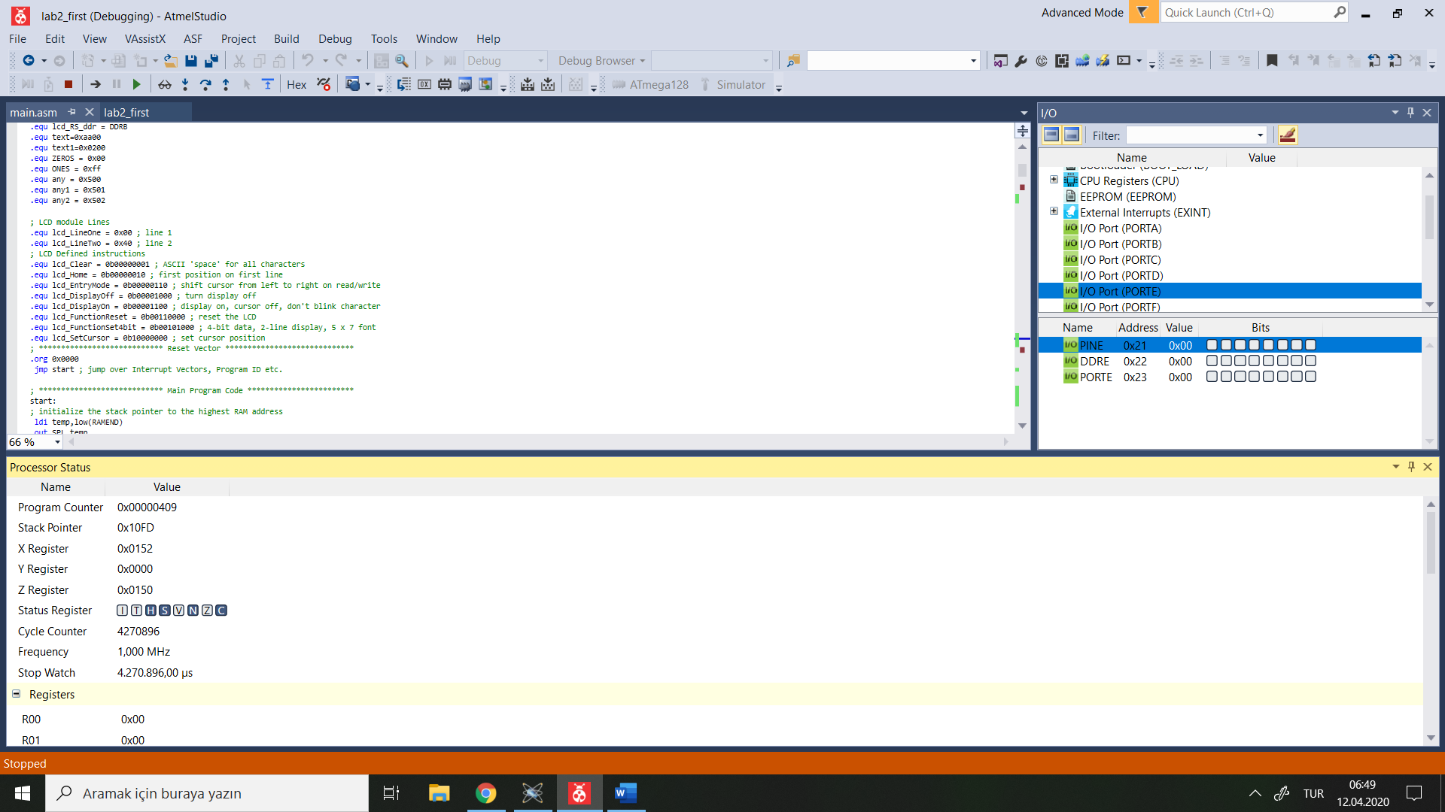

PINA has a value as 0x4F and Result is 0x9E as expected.

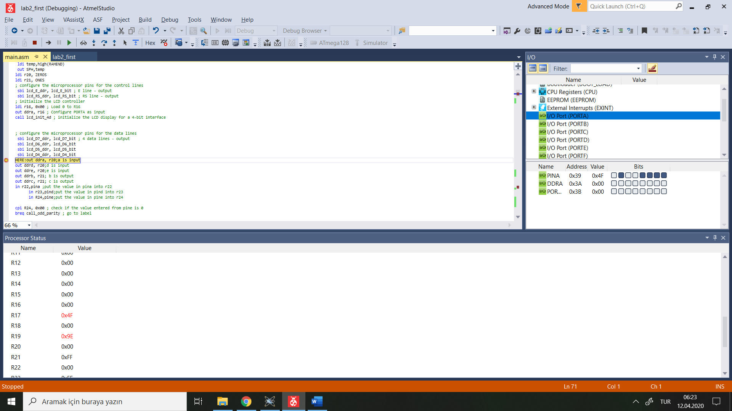

When Control input is 0x01 Case :

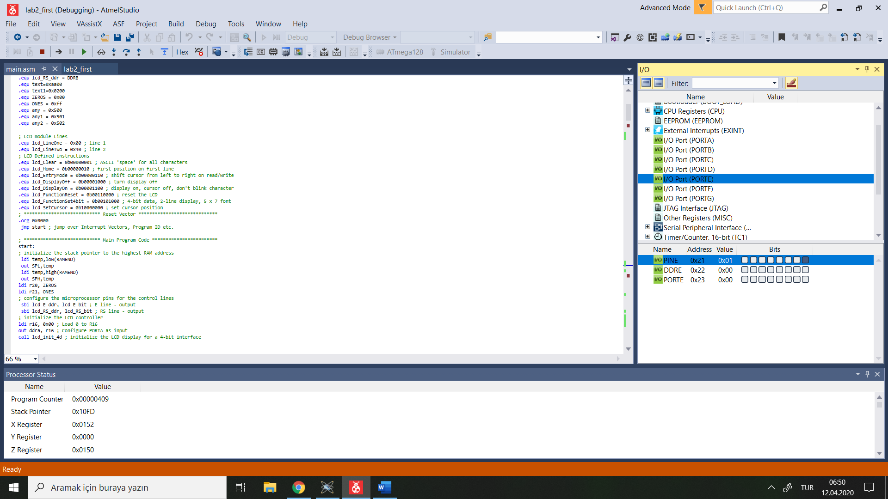

PINA has a value as 0x61. Result is 0xC3 as expected. You can see at R19.

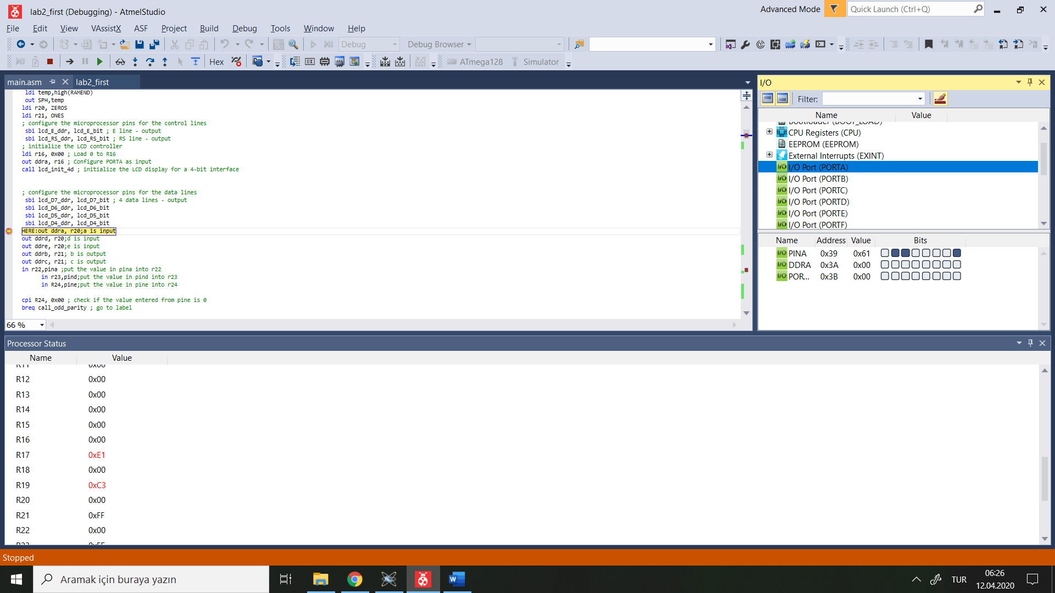

When Control input is 0x10 Case :

When A is bigger the value at R22 should same as A

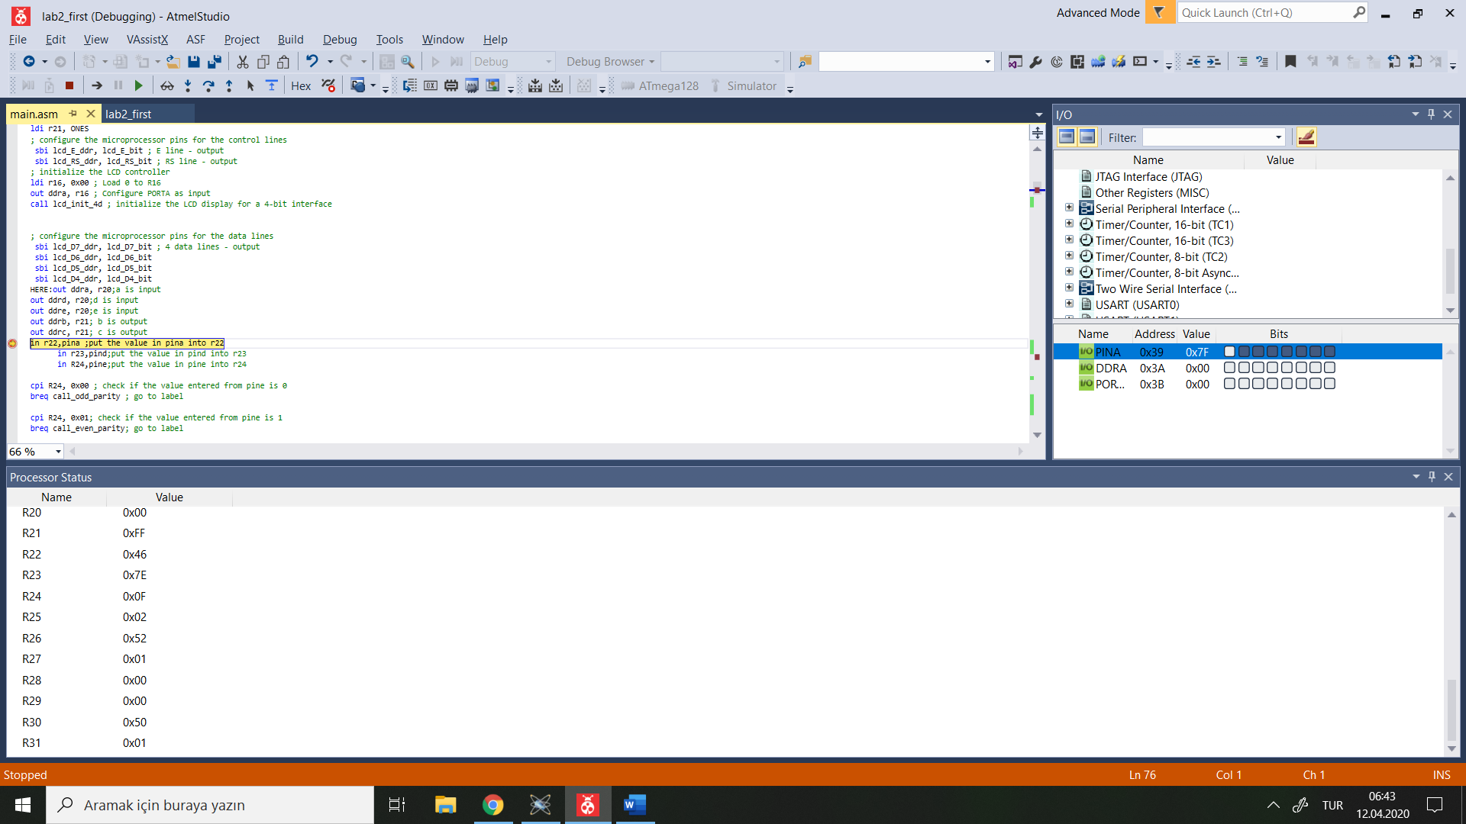

A is 0x7F

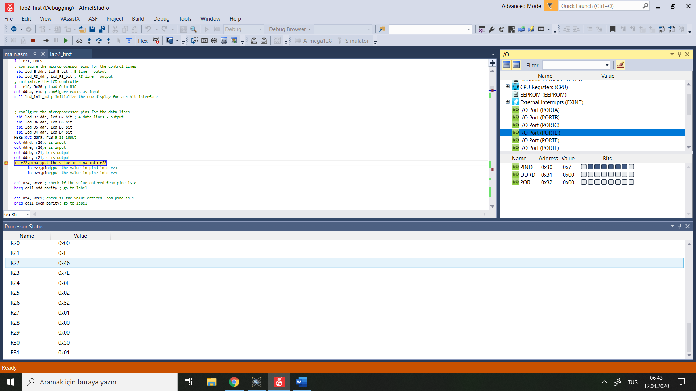

B which is at PIND is 0x7E

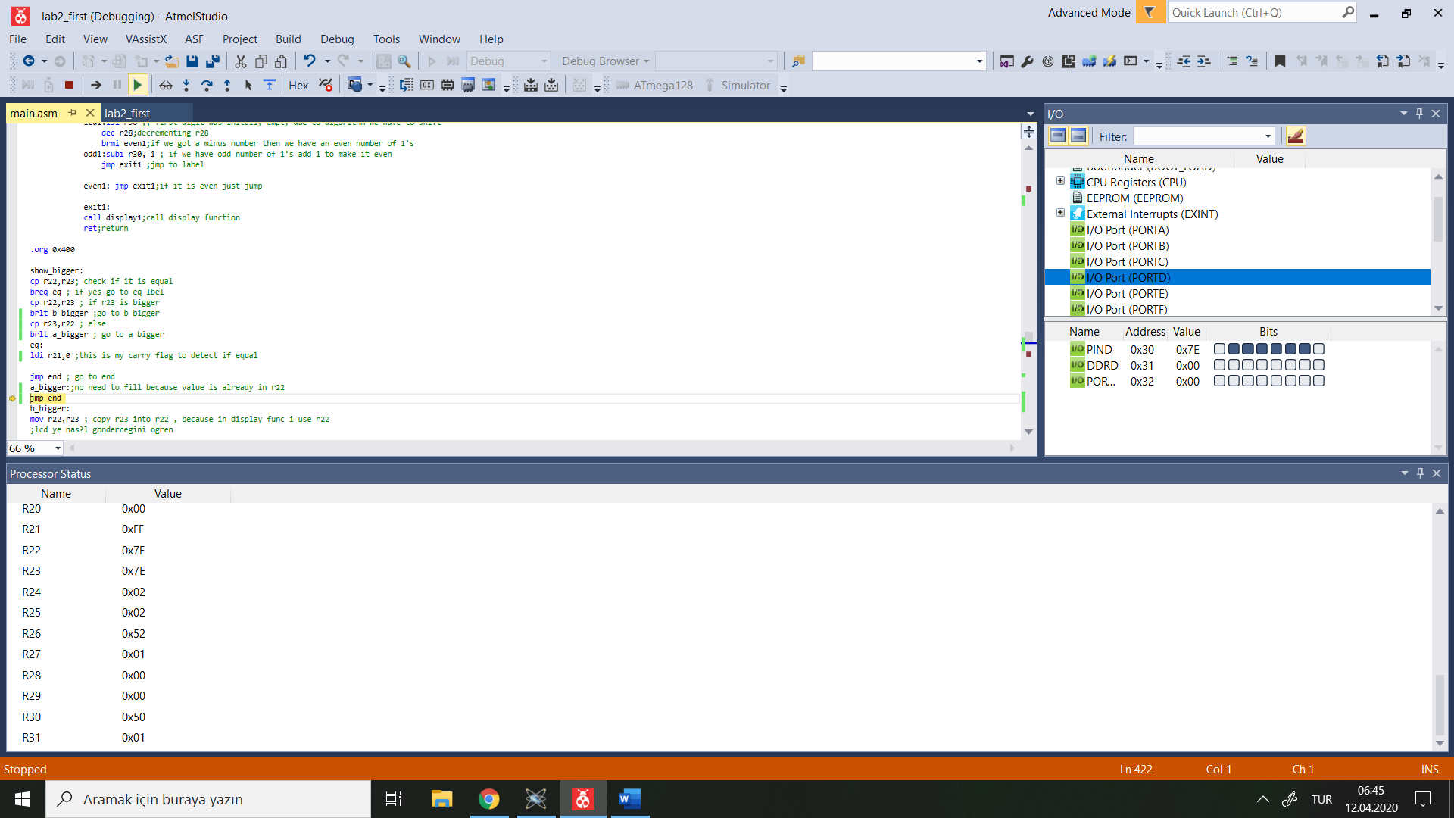

As it is seen value at R22 is 0x7F same as PINA because PINA is bigger.

When Control input is 11

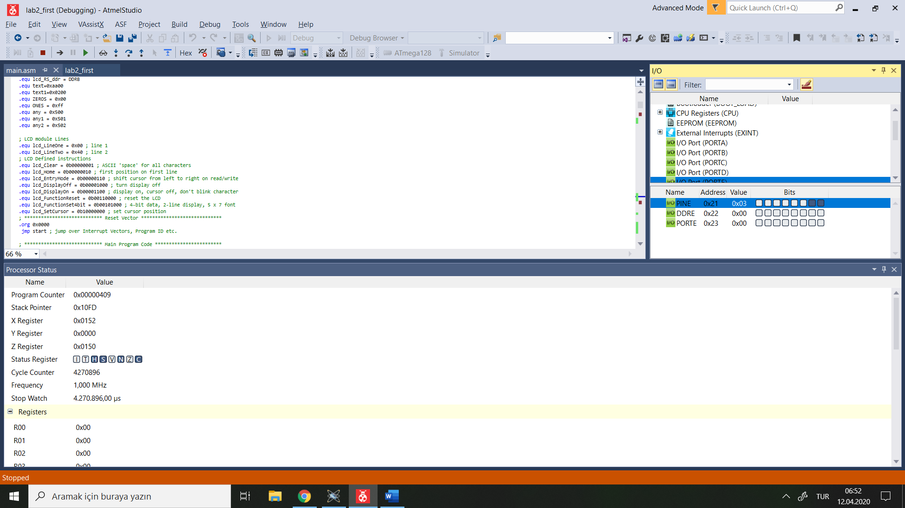

Value at R22 should show the difference

I will enter 0x07 from PINA and 0x7F from PIND, value at R22 should be 0x78

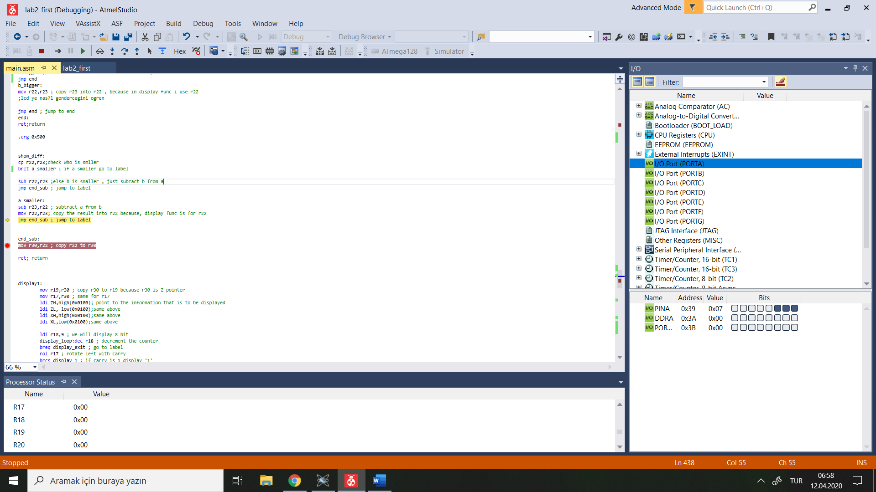

PINA is 0x07

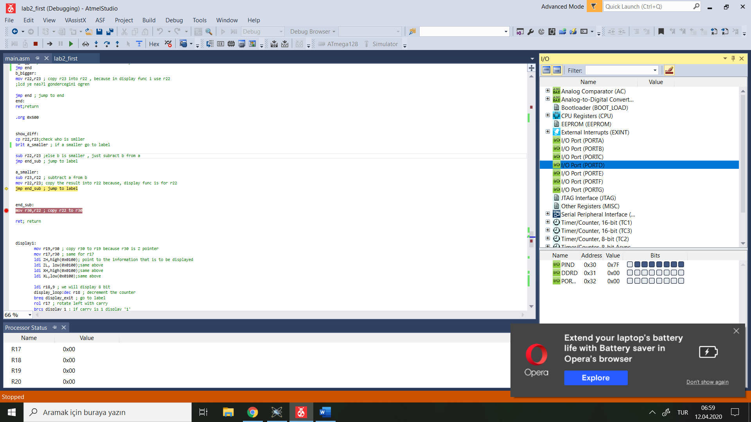

PIND is 0x7F

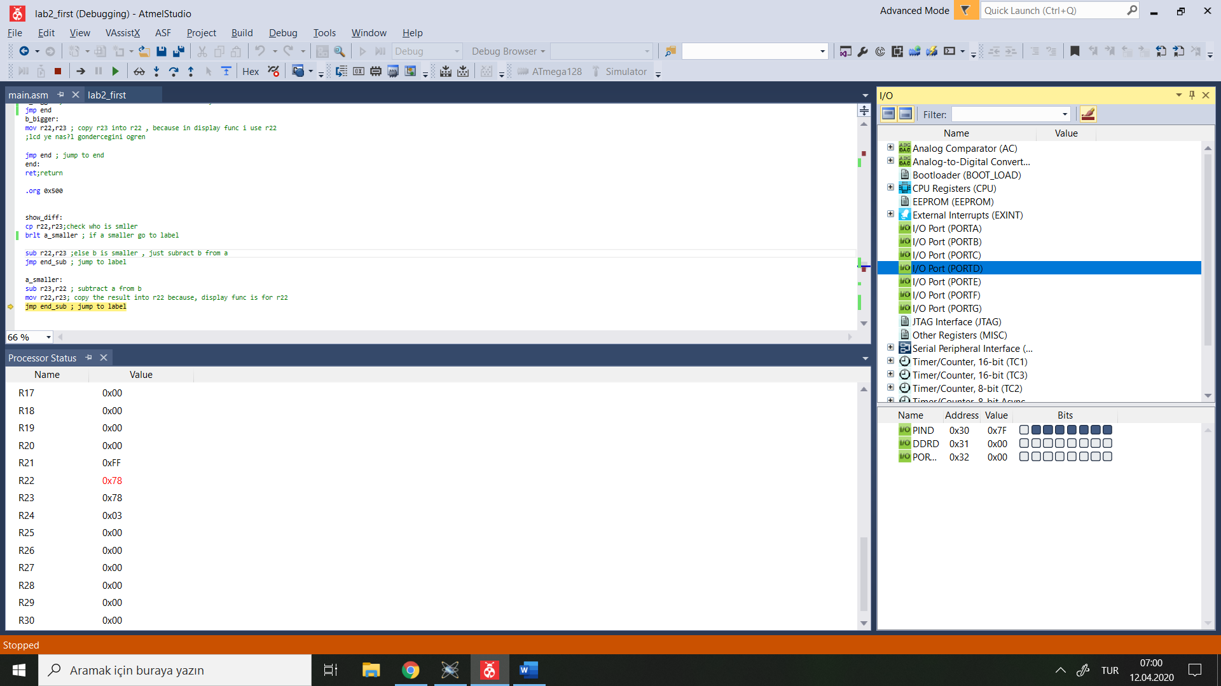

Value at R22 is 0x78 as expected

Value at Stack Pointer in main subroutine is 0x10FF

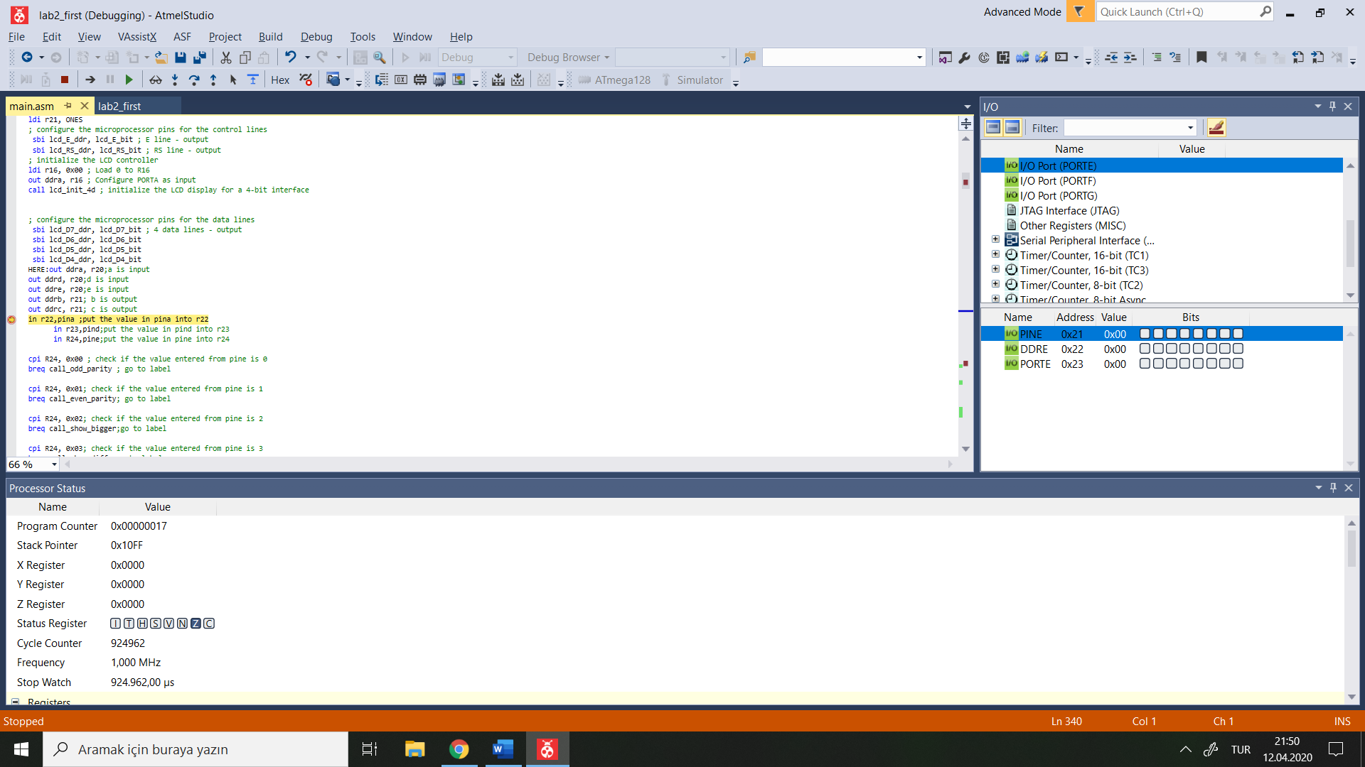

Value at Stack Pointer when Odd_Parity subroutine called is 0x10FD

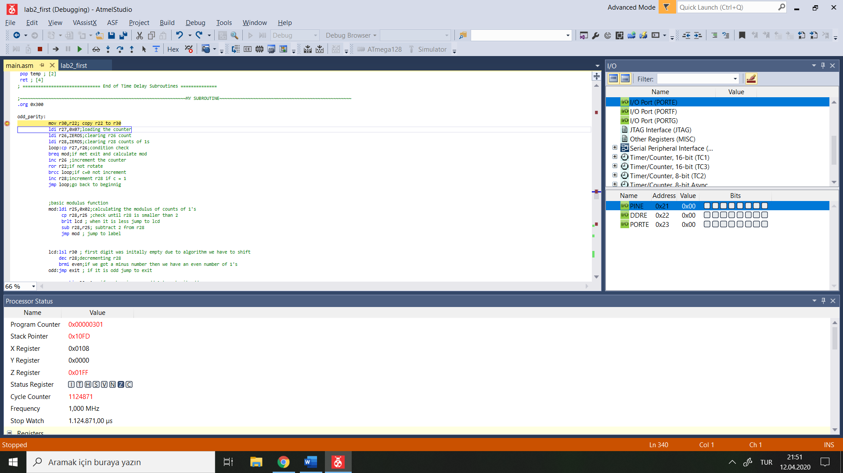

Value at Stack Pointer when Even_Parity subroutine called is 0x10FD

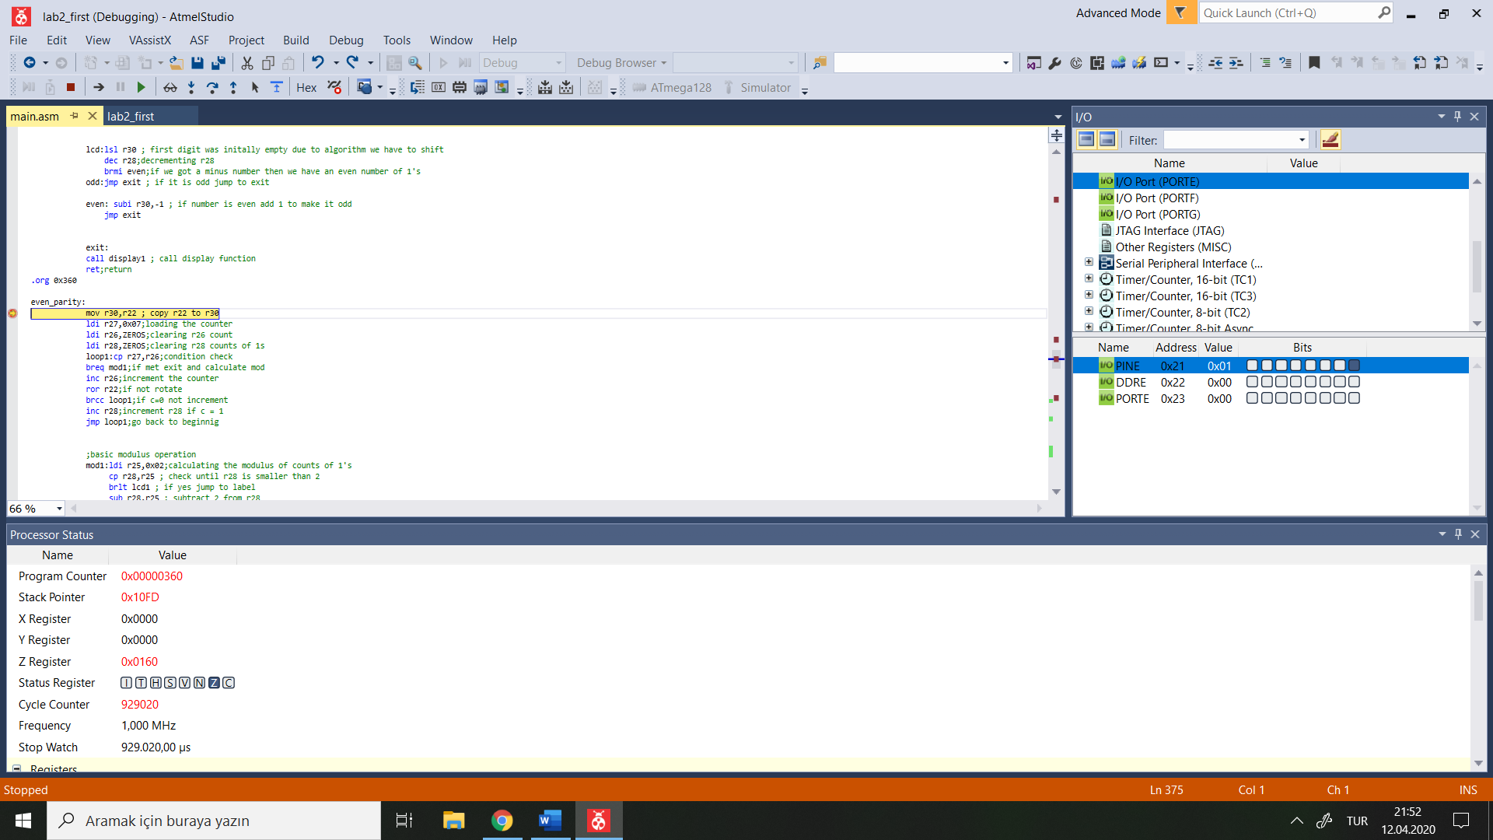

Value at Stack Pointer when Show_Bigger subroutine called is 0x10FD

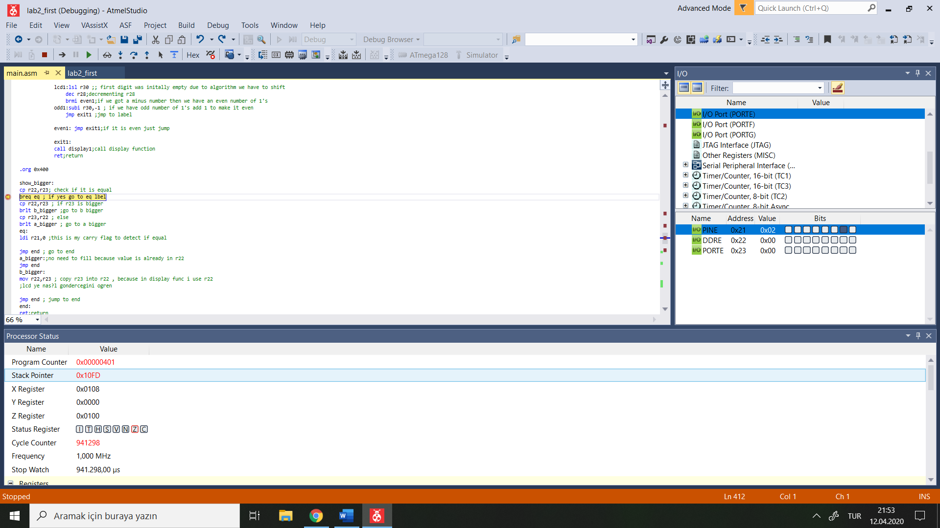

Value at Stack Pointer when Show_Diff subroutine called is 0x10FD

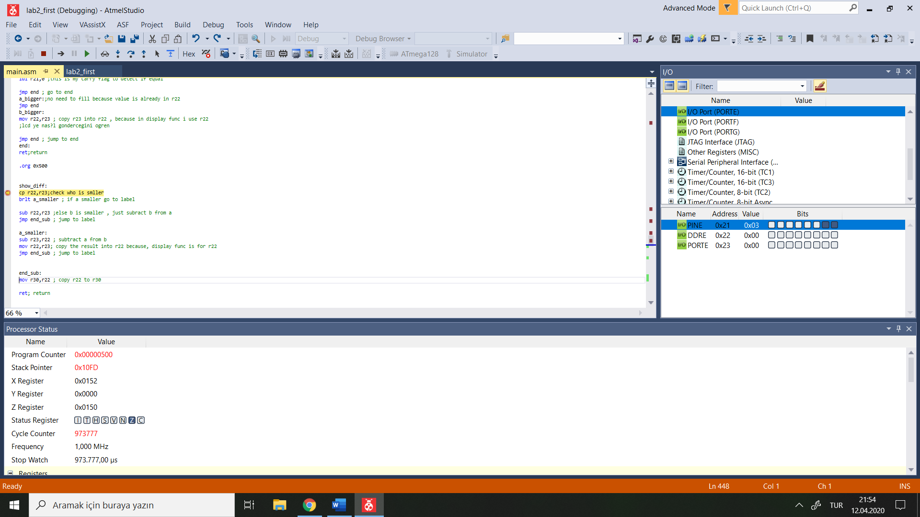

Value at Stack Pointer when Display1 subroutine called is 0x10FD

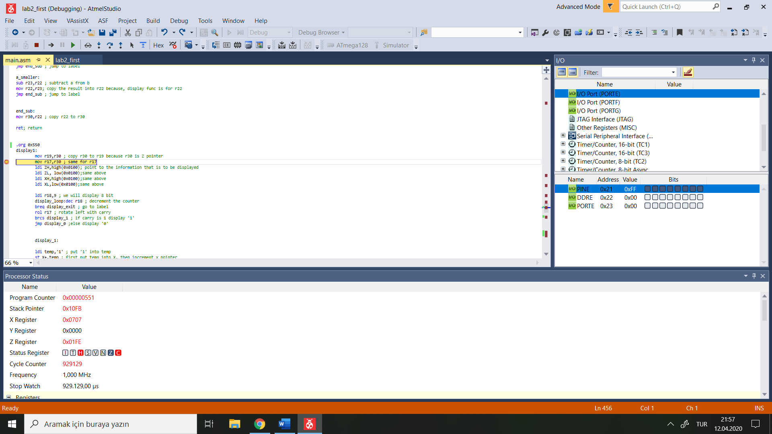

Value at Stack Pointer when Display2 subroutine called is 0x10FD

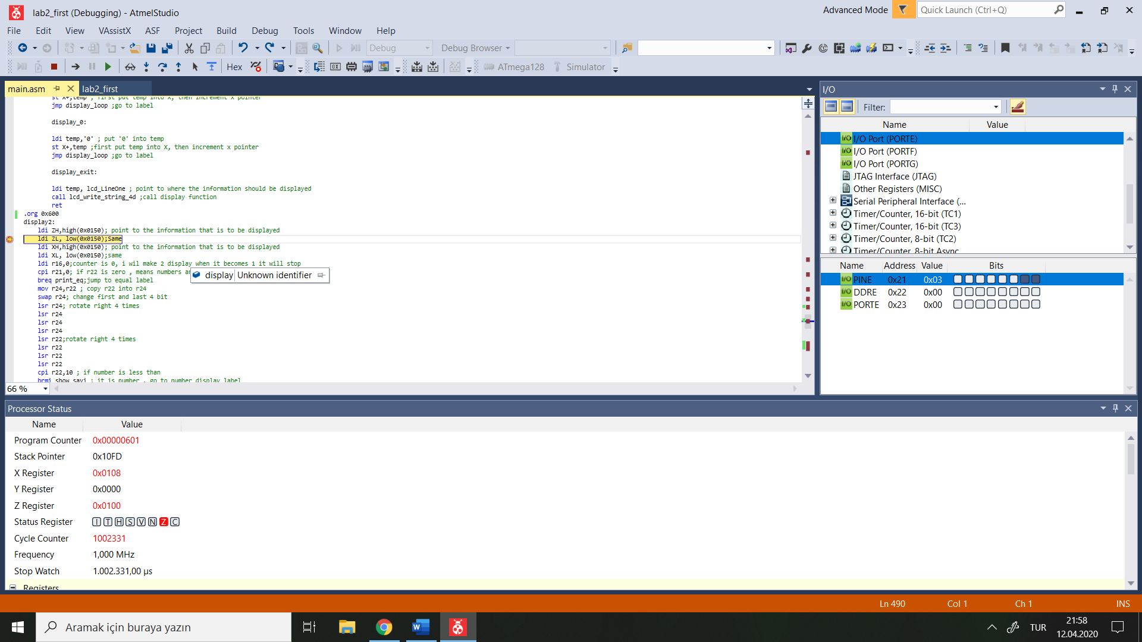

Value at Stack Pointer when display_empty_LineOne subroutine called is 0x10FD

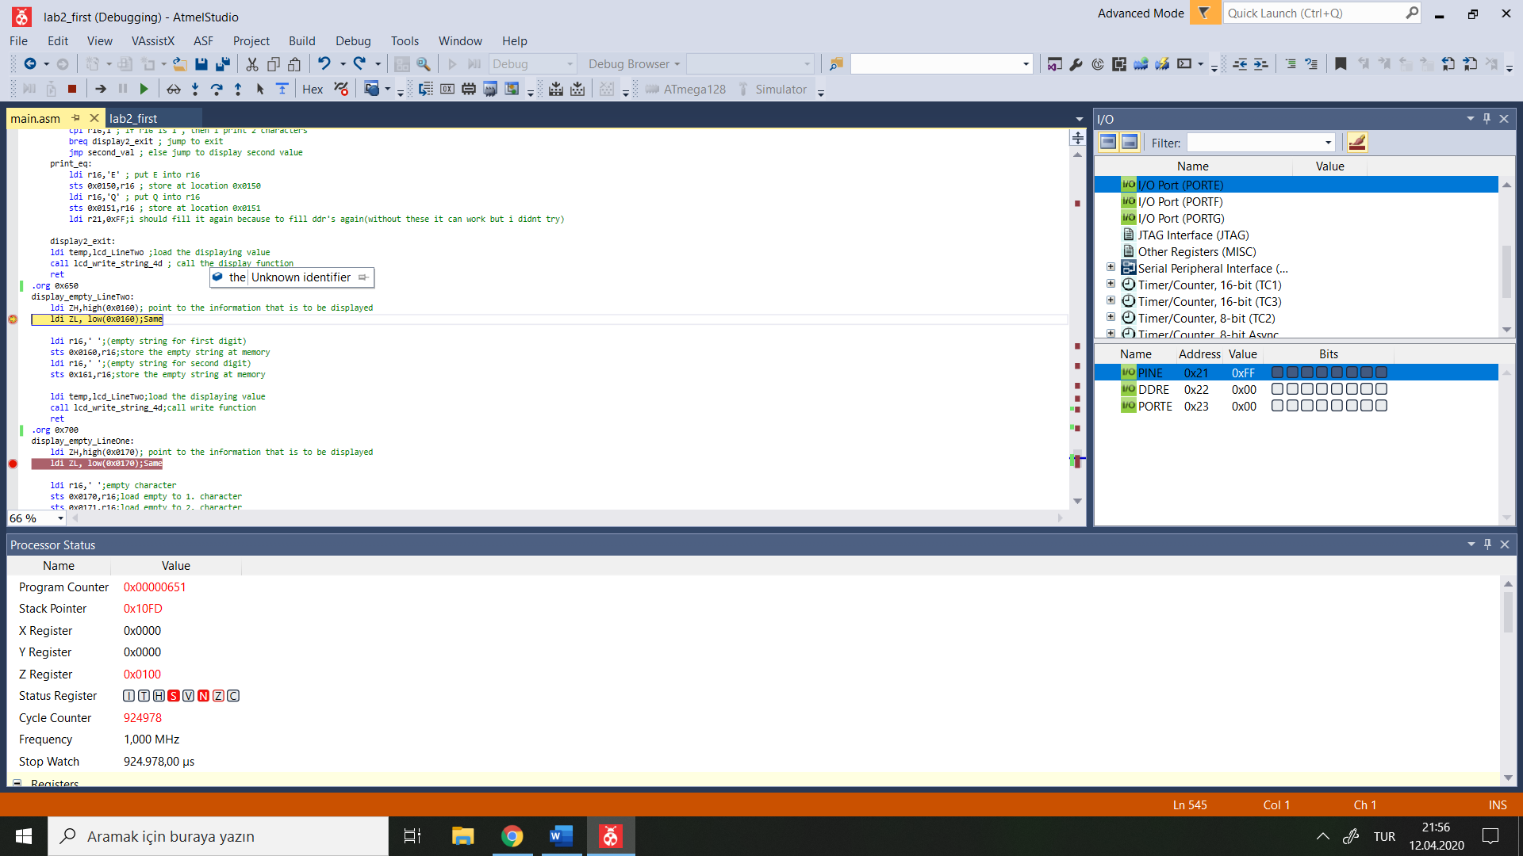

Value at Stack Pointer when display_empty_LineOne subroutine called is 0x10FD

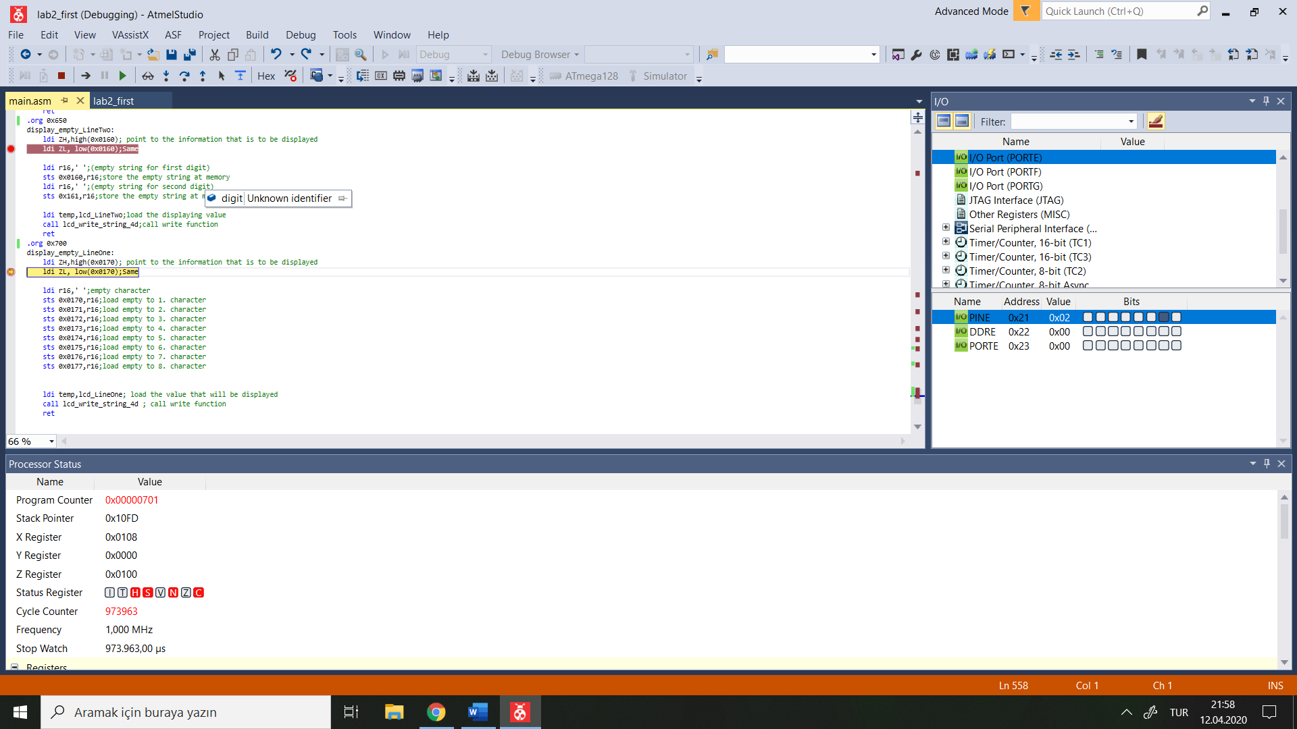

Proteus)

PINE is 00

PINA is b00000110

LCD is 00001101

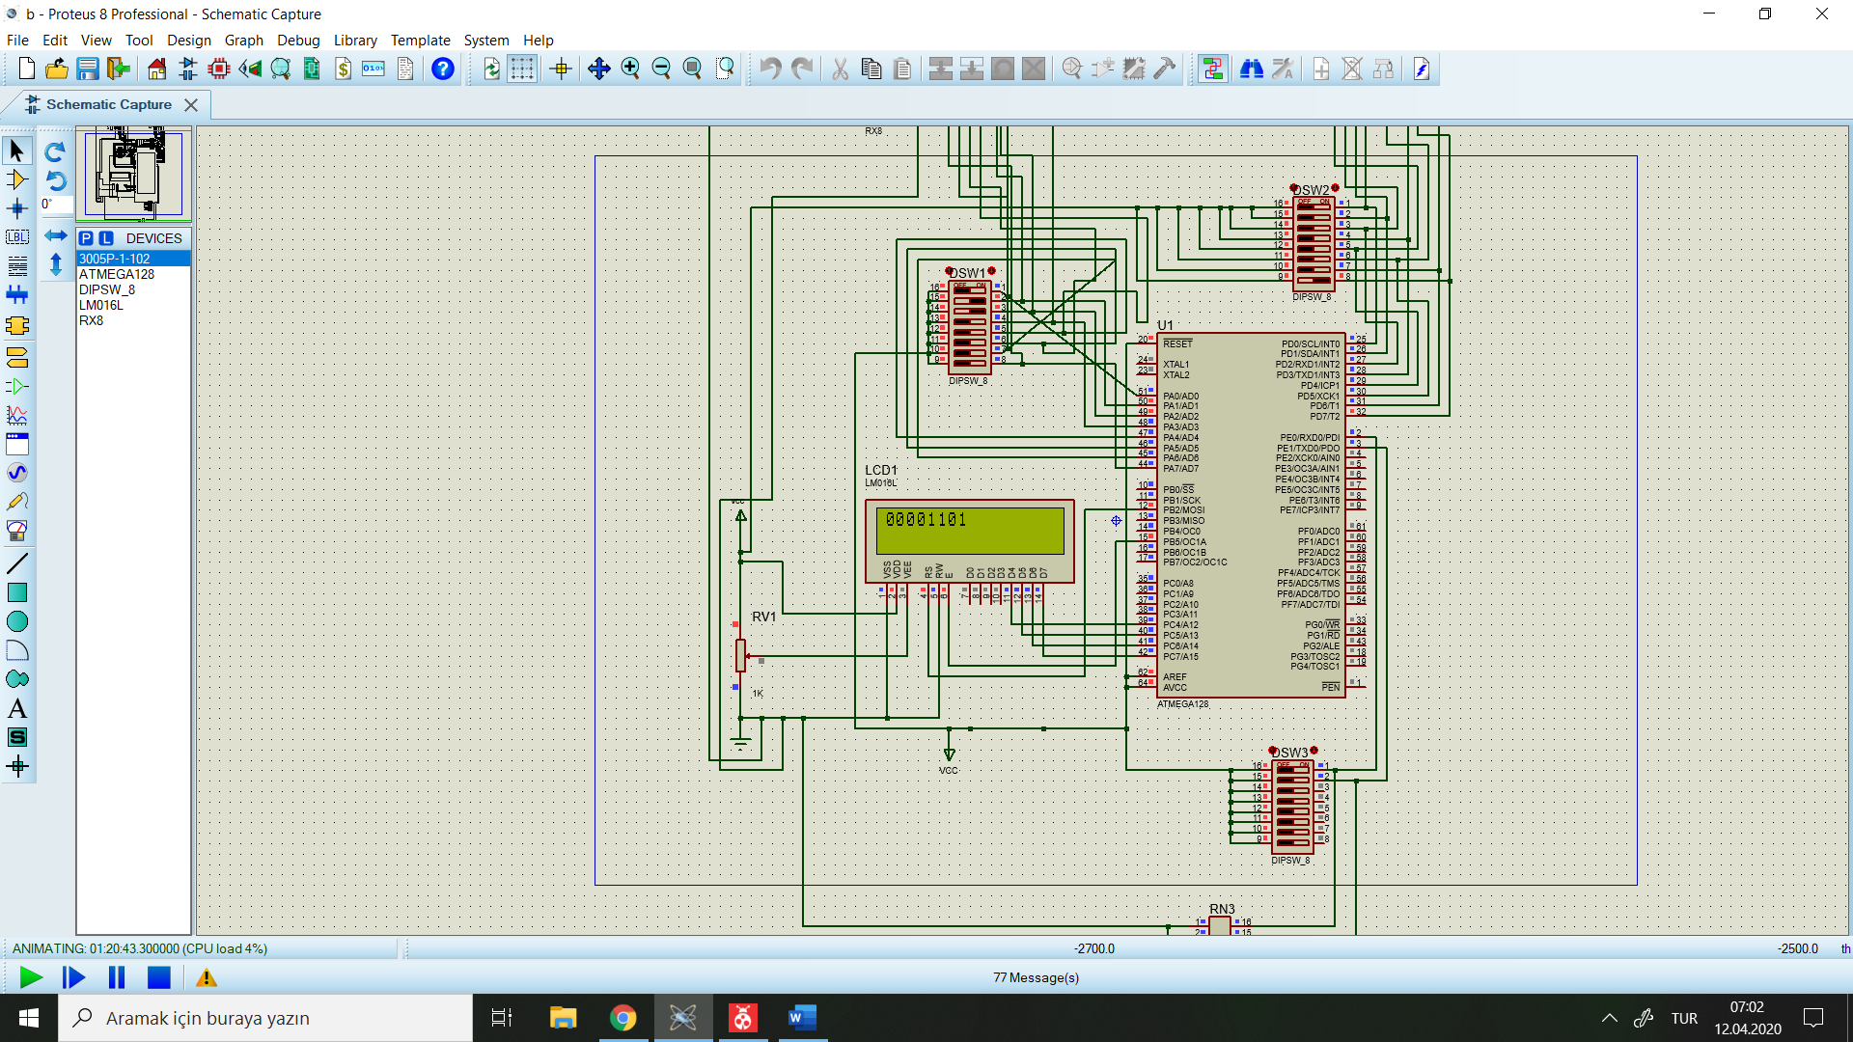

PINE is 0x01

PINA is b00001110

LCD is 00011101

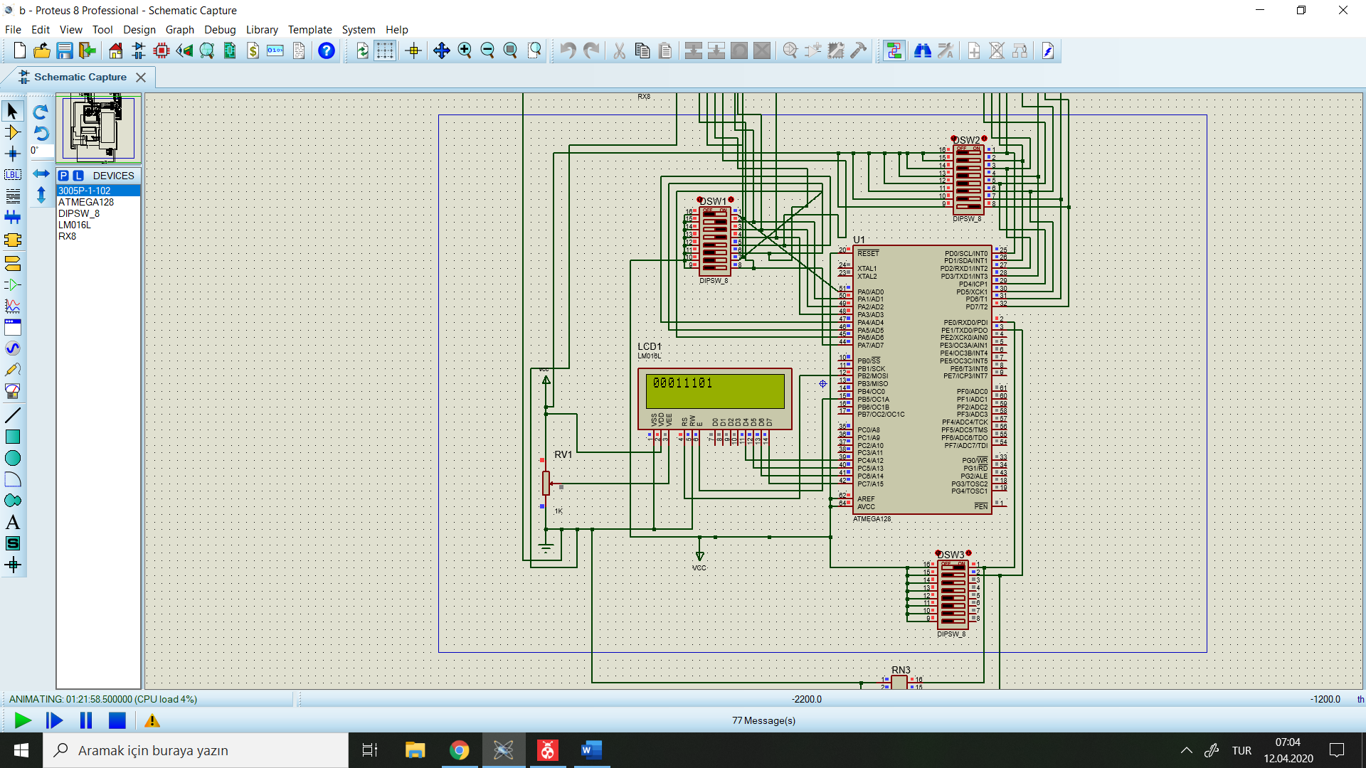

PINE is 0x10

PINA is 0x80

PIND is 0x80

LCD is ‘EQ’

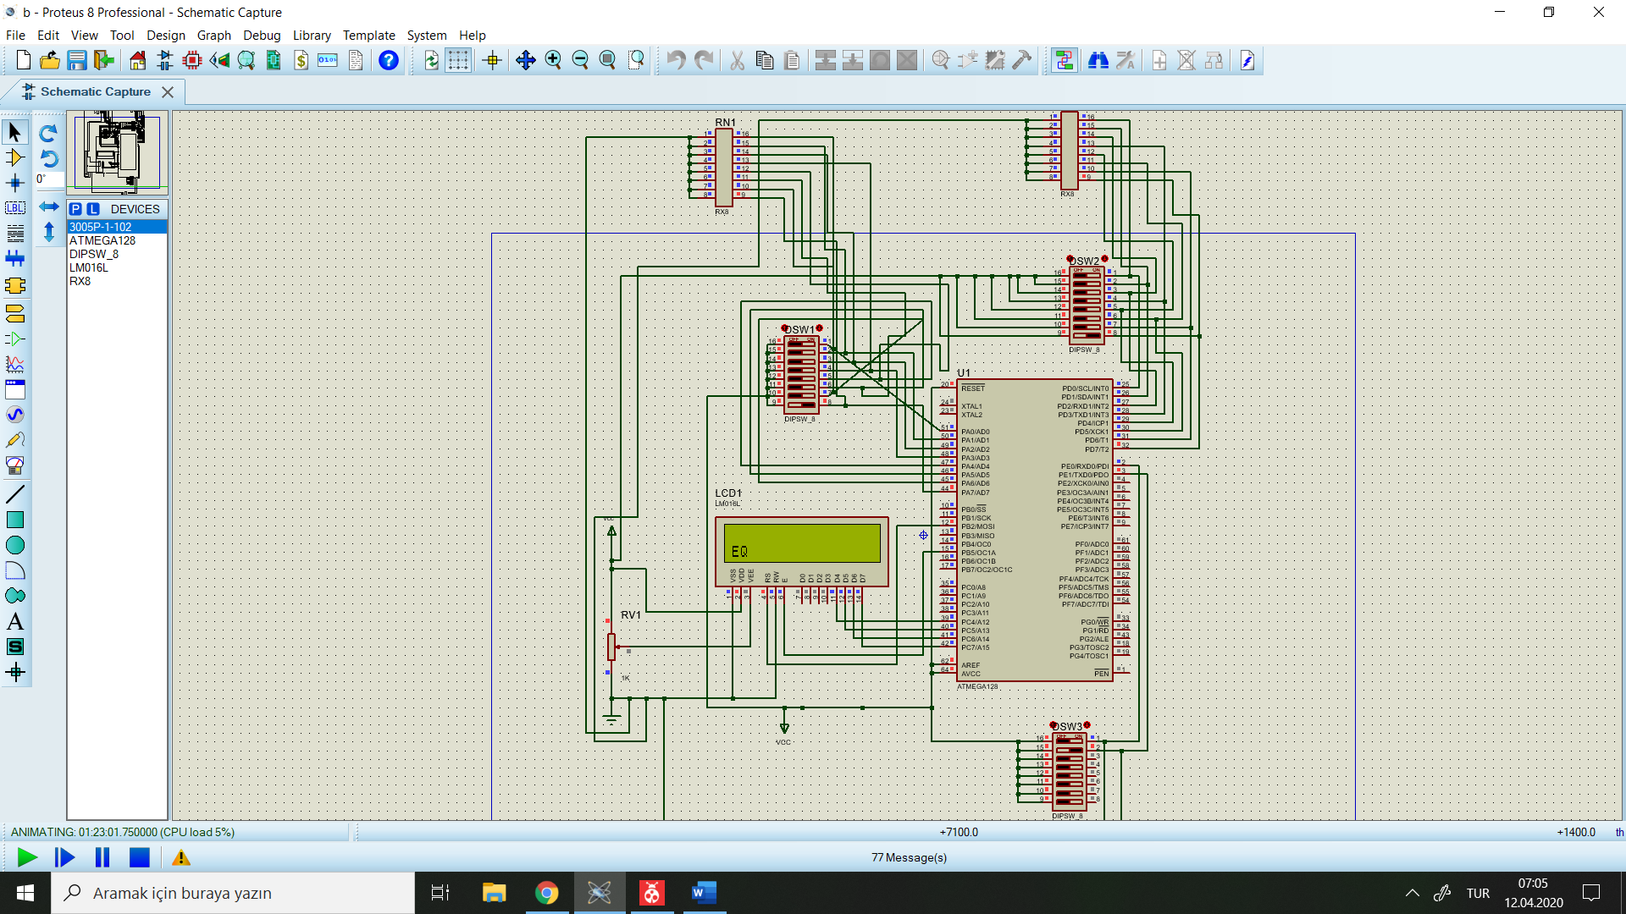

PINE is 0x01

PINA is 0x40

PIND is 0x04

LCD is 0x40

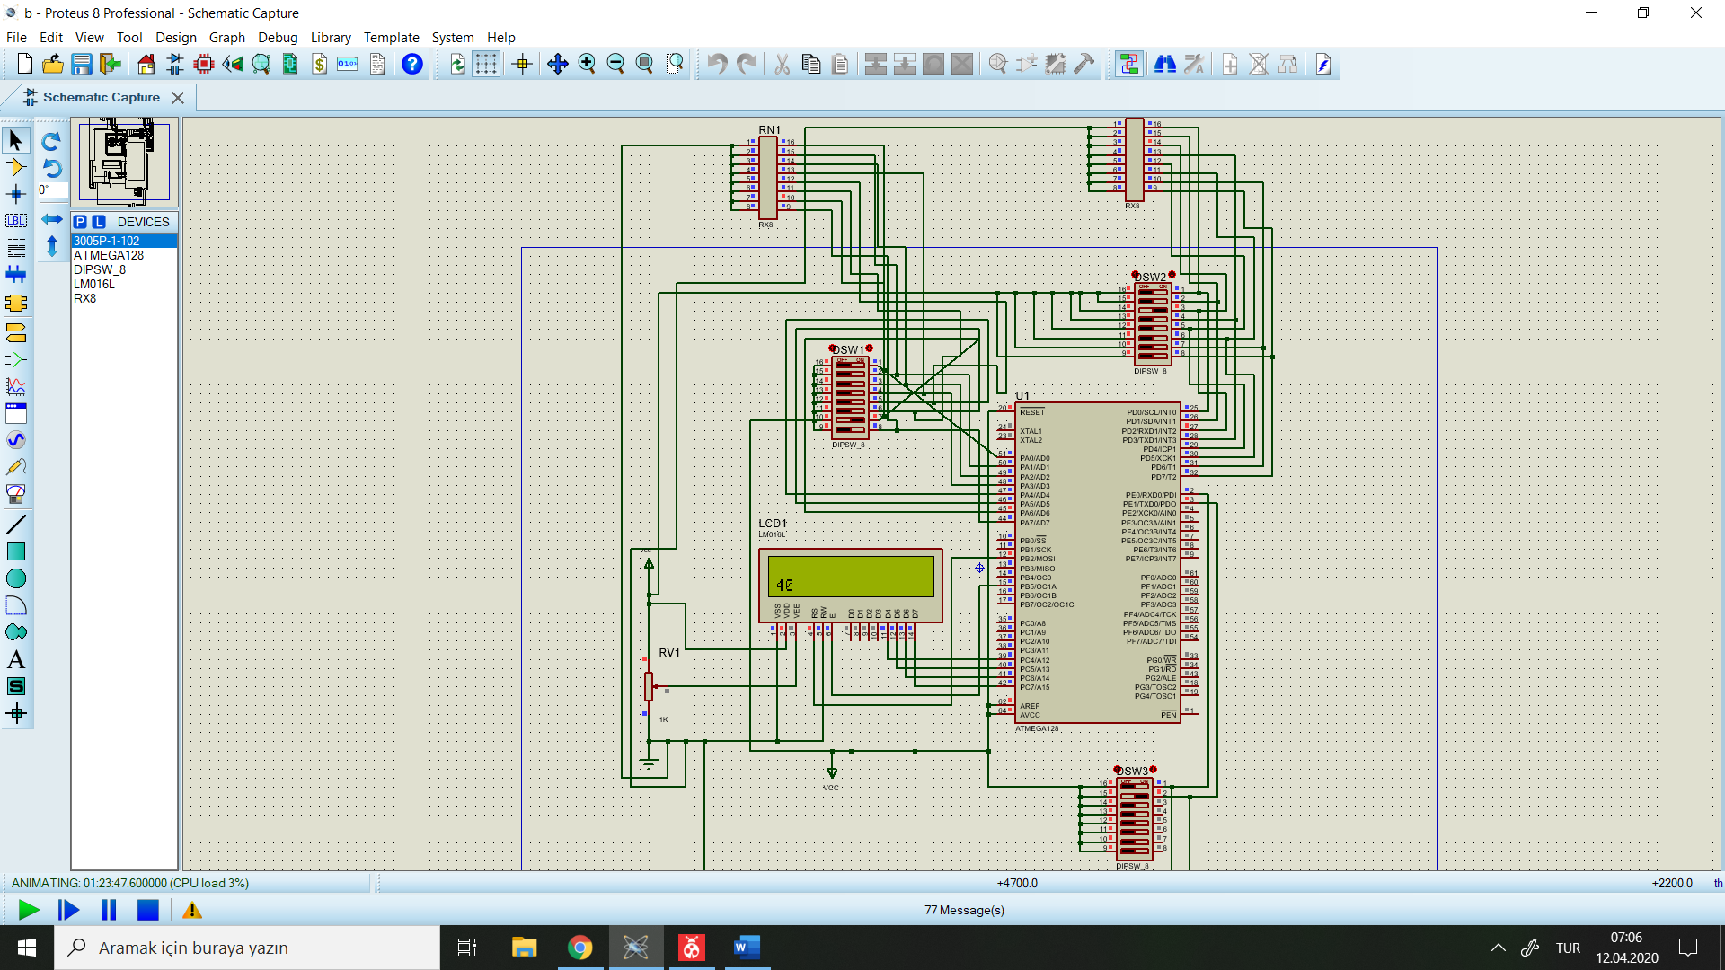

PINE is 0x01

PINA is 0x40

PIND is 0x44

LCD is 0x44

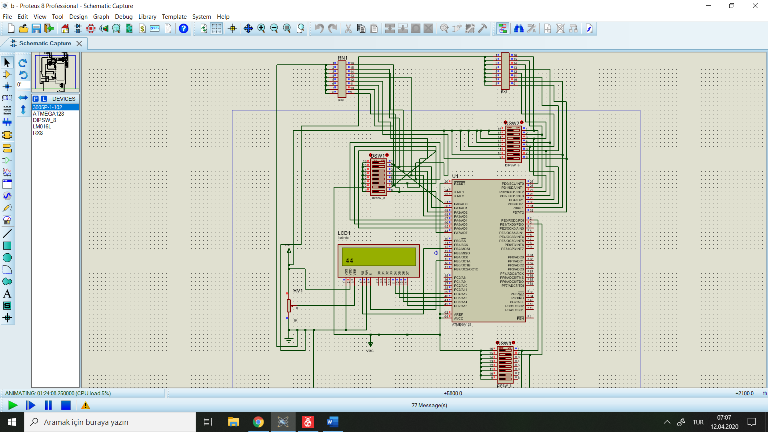

PINE is 0x11

PINA is 0x80 ( which is -128)

PIND is 0x01 ( which is 1)

LCD is 129 (1- -128 = 129) ,(in hex 81) ,(in binary 10000001)

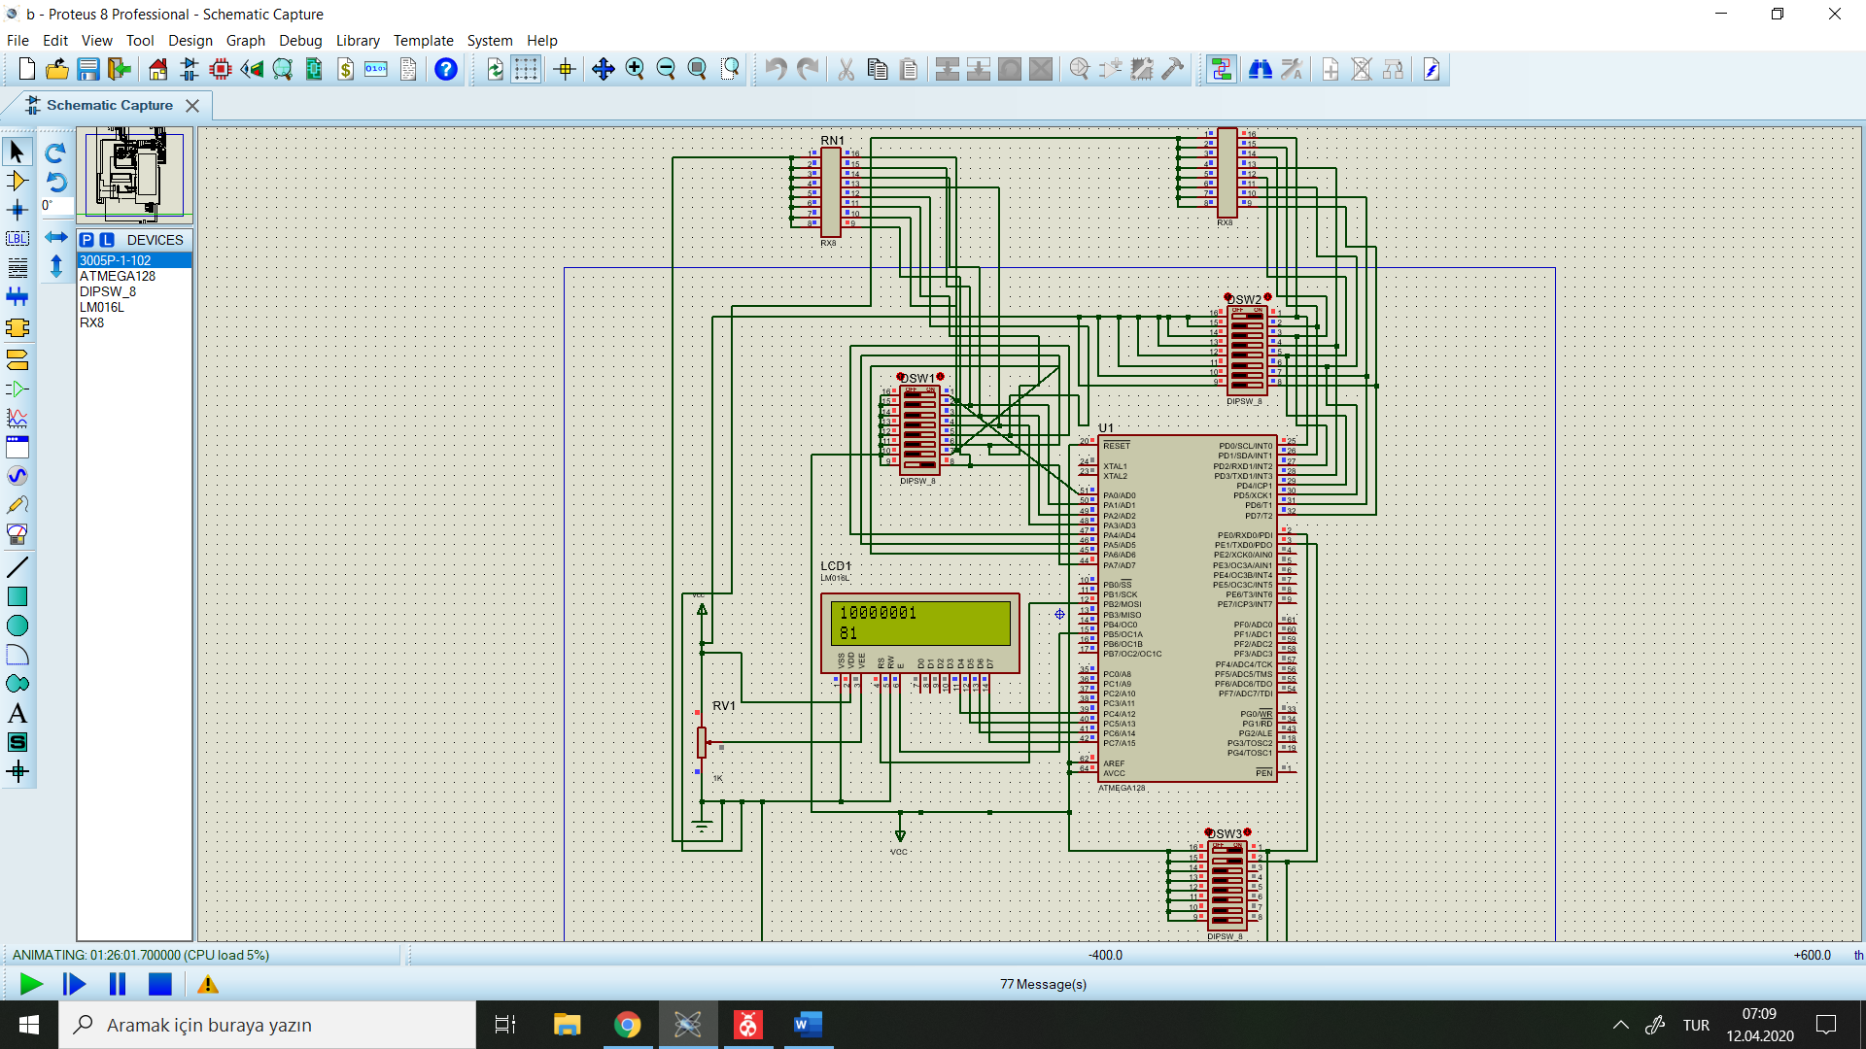

**2.2.4)**

iv.

Pseudo-code)

Define_necessary_library

Declare_lcd_ports

Initilaze_stack

Initilaze_ports

R22 <- PINA

Calculate_CRC{

R26 <- R22

Cnt<-0

Here:

IF R22 < 0 // which means most significant digit is 1

Do_eor_with_’10011000’

Cnt++

If CNT == 8

Swap R22

RETURN

Else

Shift_left_until_first_digit_becomes_1

go_to_Here

}

Display_in_Binary{

For(i = 0 ;i < 8 ; i ++){

Rotate_With_Carry(R17)

If(c==1)

Display(1)

Else

Display(0)

}

Return

}

Display_in_Hex{

Text_in_Hex <- Convert_To_Hex(R19)

Display(Test_in_Hex)

Return

}

v.

.INCLUDE "m128def.inc"

.equ fclk = 8000000 ; system clock frequency (for delays)

; register usage

.def temp = R16 ; temporary storage

; LCD interface

.equ lcd_D7_port = PORTC ; lcd D7 connection

.equ lcd_D7_bit = PORTC7

.equ lcd_D7_ddr = DDRC

.equ lcd_D6_port = PORTC ; lcd D6 connection

.equ lcd_D6_bit = PORTC6

.equ lcd_D6_ddr = DDRC

.equ lcd_D5_port = PORTC ; lcd D5 connection

.equ lcd_D5_bit = PORTC5

.equ lcd_D5_ddr = DDRC

.equ lcd_D4_port = PORTC ; lcd D4 connection

.equ lcd_D4_bit = PORTC4

.equ lcd_D4_ddr = DDRC

.equ lcd_E_port = PORTB ; lcd Enable pin

.equ lcd_E_bit = PORTB5

.equ lcd_E_ddr = DDRB

.equ lcd_RS_port = PORTB ; lcd Register Select pin

.equ lcd_RS_bit = PORTB2

.equ lcd_RS_ddr = DDRB

.equ text=0xaa00

.equ text1=0x0200

.equ ZEROS = 0x00

.equ ONES = 0xff

.equ any = 0x500

.equ any1 = 0x501

.equ any2 = 0x502

; LCD module Lines

.equ lcd_LineOne = 0x00 ; line 1

.equ lcd_LineTwo = 0x40 ; line 2

; LCD Defined instructions

.equ lcd_Clear = 0b00000001 ; ASCII 'space' for all characters

.equ lcd_Home = 0b00000010 ; first position on first line

.equ lcd_EntryMode = 0b00000110 ; shift cursor from left to right on read/write

.equ lcd_DisplayOff = 0b00001000 ; turn display off

.equ lcd_DisplayOn = 0b00001100 ; display on, cursor off, don't blink character

.equ lcd_FunctionReset = 0b00110000 ; reset the LCD

.equ lcd_FunctionSet4bit = 0b00101000 ; 4-bit data, 2-line display, 5 x 7 font

.equ lcd_SetCursor = 0b10000000 ; set cursor position

; ****************************** Reset Vector *******************************

.org 0x0000

jmp start ; jump over Interrupt Vectors, Program ID etc.

; ****************************** Main Program Code **************************

start:

; initialize the stack pointer to the highest RAM address

ldi temp,low(RAMEND);decleration of stack

out SPL,temp

ldi temp,high(RAMEND)

out SPH,temp

ldi r20, ZEROS

ldi r21, ONES

; configure the microprocessor pins for the data lines

sbi lcd_D7_ddr, lcd_D7_bit ; 4 data lines - output

sbi lcd_D6_ddr, lcd_D6_bit

sbi lcd_D5_ddr, lcd_D5_bit

sbi lcd_D4_ddr, lcd_D4_bit

out ddra, r20;a is input

out ddrb, r20;b is input

out ddrc, r20;c is input

out ddrd, r21;d is output

HERE:call read_input ;calling input function

call calculate_crc;calling crc function

call display1 ; calling binary display in firstline of lcd

call display2 ; calling hexa display in secondline of lcd

; configure the microprocessor pins for the control lines

sbi lcd_E_ddr, lcd_E_bit ; E line - output

sbi lcd_RS_ddr, lcd_RS_bit ; RS line - output

; initialize the LCD controller

ldi r16, 0x00 ; Load 0 to R16

out ddra, r16 ; Configure PORTA as input

call lcd_init_4d ; initialize the LCD display for a 4-bit interface

; endless loop

rjmp here

; ****************************** End of Main Program Code *******************

; ============================== 4-bit LCD Function Calls ======================

; Name: lcd_init_4d -- initialize the LCD module for a 4-bit data interface

lcd_init_4d:

; Power-up delay

ldi temp, 100 ; initial 40 mSec delay

call delayTx1mS

; IMPORTANT - At this point the LCD module is in the 8-bit mode and it is expecting to receive

; 8 bits of data, one bit on each of its 8 data lines, each time the 'E' line is pulsed.

;

; Since the LCD module is wired for the 4-bit mode, only the upper four data lines areconnected to

; the microprocessor and the lower four data lines are typically left open. Therefore, when

; the 'E' line is pulsed, the LCD controller will read whatever data has been set up on theupper

; four data lines and the lower four data lines will be high (due to internal pull-upcircuitry).

;

; Fortunately the 'FunctionReset' instruction does not care about what is on the lower fourbits so

; this instruction can be sent on just the four available data lines and it will beinterpreted

; properly by the LCD controller. The 'lcd_write_4' subroutine will accomplish this if the

; control lines have previously been configured properly.

; Set up the RS and E lines for the 'lcd_write_4' subroutine.

cbi lcd_RS_port, lcd_RS_bit ; select the Instruction Register (RS low)

cbi lcd_E_port, lcd_E_bit ; make sure E is initially low

; Reset the LCD controller.

ldi temp, lcd_FunctionReset ; first part of reset sequence

call lcd_write_4

ldi temp, 10 ; 4.1 mS delay (min)

call delayTx1mS

ldi temp, lcd_FunctionReset ; second part of reset sequence

call lcd_write_4

ldi temp, 200 ; 100 uS delay (min)

call delayTx1uS

ldi temp, lcd_FunctionReset ; third part of reset sequence

call lcd_write_4

ldi temp, 200 ; this delay is omitted in the data sheet

call delayTx1uS

; Preliminary Function Set instruction - used only to set the 4-bit mode.

; The number of lines or the font cannot be set at this time since the controller is still inthe

; 8-bit mode, but the data transfer mode can be changed since this parameter is determined byone

; of the upper four bits of the instruction.

ldi temp, lcd_FunctionSet4bit ; set 4-bit mode

call lcd_write_4

ldi temp, 80 ; 40 uS delay (min)

call delayTx1uS

; Function Set instruction

ldi temp, lcd_FunctionSet4bit ; set mode, lines, and font

call lcd_write_instruction_4d

ldi temp, 80 ; 40 uS delay (min)

call delayTx1uS

; The next three instructions are specified in the data sheet as part of the initialization routine,

; so it is a good idea (but probably not necessary) to do them just as specified and then redo them

; later if the application requires a different configuration.

; Display On/Off Control instruction

ldi temp, lcd_DisplayOff ; turn display OFF

call lcd_write_instruction_4d

ldi temp, 80 ; 40 uS delay (min)

call delayTx1uS

; Clear Display instruction

ldi temp, lcd_Clear ; clear display RAM

call lcd_write_instruction_4d

ldi temp, 4 ; 1.64 mS delay (min)

call delayTx1mS

; Entry Mode Set instruction

ldi temp, lcd_EntryMode ; set desired shift characteristics

call lcd_write_instruction_4d

ldi temp, 80 ; 40 uS delay (min)

call delayTx1uS

; This is the end of the LCD controller initialization as specified in the data sheet, but the display

; has been left in the OFF condition. This is a good time to turn the display back ON.

; Display On/Off Control instruction

ldi temp, lcd_DisplayOn ; turn the display ON

call lcd_write_instruction_4d

ldi temp, 80 ; 40 uS delay (min)

call delayTx1uS

ret

; ---------------------------------------------------------------------------

; Name: lcd_write_string_4d

; Purpose: display a string of characters on the LCD

; Entry: ZH and ZL pointing to the start of the string

; (temp) contains the desired DDRAM address at which to start the display

; Exit: no parameters

; Notes: the string must end with a null (0)

; uses time delays instead of checking the busy flag

lcd_write_string_4d:

; preserve registers

push ZH ; preserve pointer registers

push ZL

; fix up the pointers for use with the 'lpm' instruction

;lsl ZL ; shift the pointer one bit left for the lpm instruction

;rol ZH

; set up the initial DDRAM address

ori temp, lcd_SetCursor ; convert the plain address to a set cursor instruction

call lcd_write_instruction_4d ; set up the first DDRAM address

ldi temp, 80 ; 40 uS delay (min)

call delayTx1uS

; write the string of characters

lcd_write_string_4d_01:

ld temp, Z+ ; get a character

cpi temp, 0 ; check for end of string

breq lcd_write_string_4d_02 ; done

; arrive here if this is a valid character

call lcd_write_character_4d ; display the character

ldi temp, 80 ; 40 uS delay (min)

call delayTx1uS

rjmp lcd_write_string_4d_01 ; not done, send another character

; arrive here when all characters in the message have been sent to the LCD module

lcd_write_string_4d_02:

pop ZL ; restore pointer registers

pop ZH

ret

; ---------------------------------------------------------------------------

; Name: lcd_write_character_4d

; Purpose: send a byte of information to the LCD data register

; Entry: (temp) contains the data byte

; Exit: no parameters

; Notes: does not deal with RW (busy flag is not implemented)

lcd_write_character_4d:

sbi lcd_RS_port, lcd_RS_bit ; select the Data Register (RS high)

cbi lcd_E_port, lcd_E_bit ; make sure E is initially low

call lcd_write_4 ; write the upper 4-bits of the data

swap temp ; swap high and low nibbles

call lcd_write_4 ; write the lower 4-bits of the data

ret

; ---------------------------------------------------------------------------

; Name: lcd_write_instruction_4d -- Send a byte of information to the LCD instruction register

lcd_write_instruction_4d:

cbi lcd_RS_port, lcd_RS_bit ; select the Instruction Register (RS low)

cbi lcd_E_port, lcd_E_bit ; make sure E is initially low

call lcd_write_4 ; write the upper 4-bits of the instruction

swap temp ; swap high and low nibbles

call lcd_write_4 ; write the lower 4-bits of the instruction

ret

; ---------------------------------------------------------------------------

; Name: lcd_write_4 Send 4-bits of information to the LCD module

; Entry: (temp) contains a byte of data with the desired 4-bits in the upper nibble

; (RS) is configured for the desired LCD register

; (E) is low

; (RW) is low

lcd_write_4:

; set up D7

sbi lcd_D7_port, lcd_D7_bit ; assume that the D7 data is '1'

sbrs temp, 7 ; check the actual data value

cbi lcd_D7_port, lcd_D7_bit ; arrive here only if the data was actually '0'

; set up D6

sbi lcd_D6_port, lcd_D6_bit ; repeat for each data bit

sbrs temp, 6

cbi lcd_D6_port, lcd_D6_bit

; set up D5

sbi lcd_D5_port, lcd_D5_bit

sbrs temp, 5

cbi lcd_D5_port, lcd_D5_bit

; set up D4

sbi lcd_D4_port, lcd_D4_bit

sbrs temp, 4

cbi lcd_D4_port, lcd_D4_bit

; write the data

; 'Address set-up time' (40 nS)

sbi lcd_E_port, lcd_E_bit ; Enable pin high

call delay1uS ; implement 'Data set-up time' (80 nS) and 'Enable pulse width' (230 nS)

cbi lcd_E_port, lcd_E_bit ; Enable pin low

call delay1uS ; implement 'Data hold time' (10 nS) and 'Enable cycle time' (500 nS)

ret

; ============================== End of 4-bit LCD Subroutines ===============

; ============================== Time Delay Subroutines =====================

; Name: delayYx1mS Delay of (YH:YL) x 1 mS

delayYx1mS:

call delay1mS ; delay for 1 mS

sbiw YH:YL, 1 ; update the the delay counter

brne delayYx1mS ; counter is not zero

; arrive here when delay counter is zero (total delay period is finished)

ret

; ---------------------------------------------------------------------------

; Name: delayTx1mS Provide a delay of (temp) x 1 mS

delayTx1mS:

call delay1mS ; delay for 1 mS

dec temp ; update the delay counter

brne delayTx1mS ; counter is not zero

; arrive here when delay counter is zero (total delay period is finished)

ret

; ---------------------------------------------------------------------------

; Name: delay1mS -- Delay of 1 mS

delay1mS:

push YL ; [2] preserve registers

push YH ; [2]

ldi YL, low (((fclk/1000)-18)/4) ; [1] delay counter

ldi YH, high(((fclk/1000)-18)/4) ; [1]

delay1mS_01:

sbiw YH:YL, 1 ; [2] update the the delay counter

brne delay1mS_01 ; [2] delay counter is not zero

; arrive here when delay counter is zero

pop YH ; [2] restore registers

pop YL ; [2]

ret ; [4]

; ---------------------------------------------------------------------------

; Name: delayTx1uS Delay of (temp) x 1 uS with a 8 MHz clock frequency

delayTx1uS:

call delay1uS ; delay for 1 uS

dec temp ; decrement the delay counter

brne delayTx1uS ; counter is not zero

; arrive here when delay counter is zero (total delay period is finished)

ret

; ---------------------------------------------------------------------------

; Name: delay1uS

; Purpose: Delay of 1 uS with a 8 MHz clock frequency

delay1uS:

push temp ; [2] Consume clock cycles

pop temp ; [2]

ret ; [4]

; ============================== End of Time Delay Subroutines ==============

;~~~~~~~~~~~~~~~~~~~~~~~~~~~~~~~~~~~~~~~~~~~~~~~~~~~~~~~~~~~~~~~~MY SUBROUTINE~~~~~~~~~~~~~~~~~~~~~~~~~~~~~~~~~~~~~~~~~~~~~~~~~~~

read_input:

in r22,pina ;putting pina into r22

ret ; end of read_input function

calculate_crc:

mov r26,r22 ;copying r22 to r26

ldi r24,0x13 ; loading 0x10011 into r24

lsl r24 ; i shift 3 times to make it 0x10011000

lsl r24 ;

lsl r24

ldi r25,0x00 ; loading counter value

this:cpi r26,0x00 ; comparing r26 with zero

brpl sll ; if r26 is plus which means there is 0 in the beginning there will be shifting

e_or:eor r26,r24 ;if 1 in the beginning it will make eor

jmp this ; jump to this

sll:lsl r26 ; shift left to r26

inc r25 ; increment counter

cpi r25,0x08 ; if we do 8 times eor crc is done

breq exit ; jump to exit

jmp e_or ; if it doesnt jump to exit contiune to do eor

exit:

swap r26 ; answer is in first 4 bit, i changed it last 4 bit

ret;return

.org 0x150

display1:

mov r17,r26 ; i moved it r17 because r26 is X pointers value

mov r19,r26; same but for hexadisplay i could call this in display2

ldi ZH,high(0x0100); point to the information that is to be displayed

ldi ZL, low(0x0100);same

ldi XH,high(0x0100);same;

ldi XL,low(0x0100);same

swap r17 ; i agained swap because i will rotate left, it will be easy

ldi r18,5; it will print 4 digit

display_loop:dec r18; decrement the counter

breq display_exit; if counter is 0 then exit

rol r17 ; rotate left with carry

brcs display_1 ; if carry is 1 it will display 1

jmp display_0 ; else it will display 0

display_1:

ldi temp,'1' ; load 1 into temp

st X+,temp ; put temp to x pointer and increment x

jmp display_loop ; go to display loop again

display_0:

ldi temp,'0'; load 0 into temp

st X+,temp ; load temp into x pointer and increment x

jmp display_loop ; go to display loop again

display_exit:

ldi temp, lcd_LineOne ; point to where the information should be displayed

call lcd_write_string_4d ; calling the lcd writing function

ret ; end

.org 0x300

display2:

ldi ZH,high(0x0200); point to the information that is to be displayed

ldi ZL, low(0x0200); same

cpi r19,10; compare the number with 10

brlt show_sayi ;if it is less than 10 it is a number

jmp show_char ; else it is a character such as A,B,C,D,E,F

show_sayi:subi r19,-48 ; add 48 to number because 0 = 49 , 1=50 etc. in Ascii

jmp display2_exit ; jump to exit

show_char:subi r19,-55; add 55 because A=10's asci is 55, B=11 is 56 etc.in Ascii

jmp display2_exit ;jump to exit

display2_exit:;

ldi temp,lcd_LineTwo;point to where the information should be displayed

sts 0x0200,r19;store r19 into location0x0200

call lcd_write_string_4d ;call writing function

ret;end

vi.

R26 should show the result.

When I enter 0x3F from PINA R26 should be 0x0D

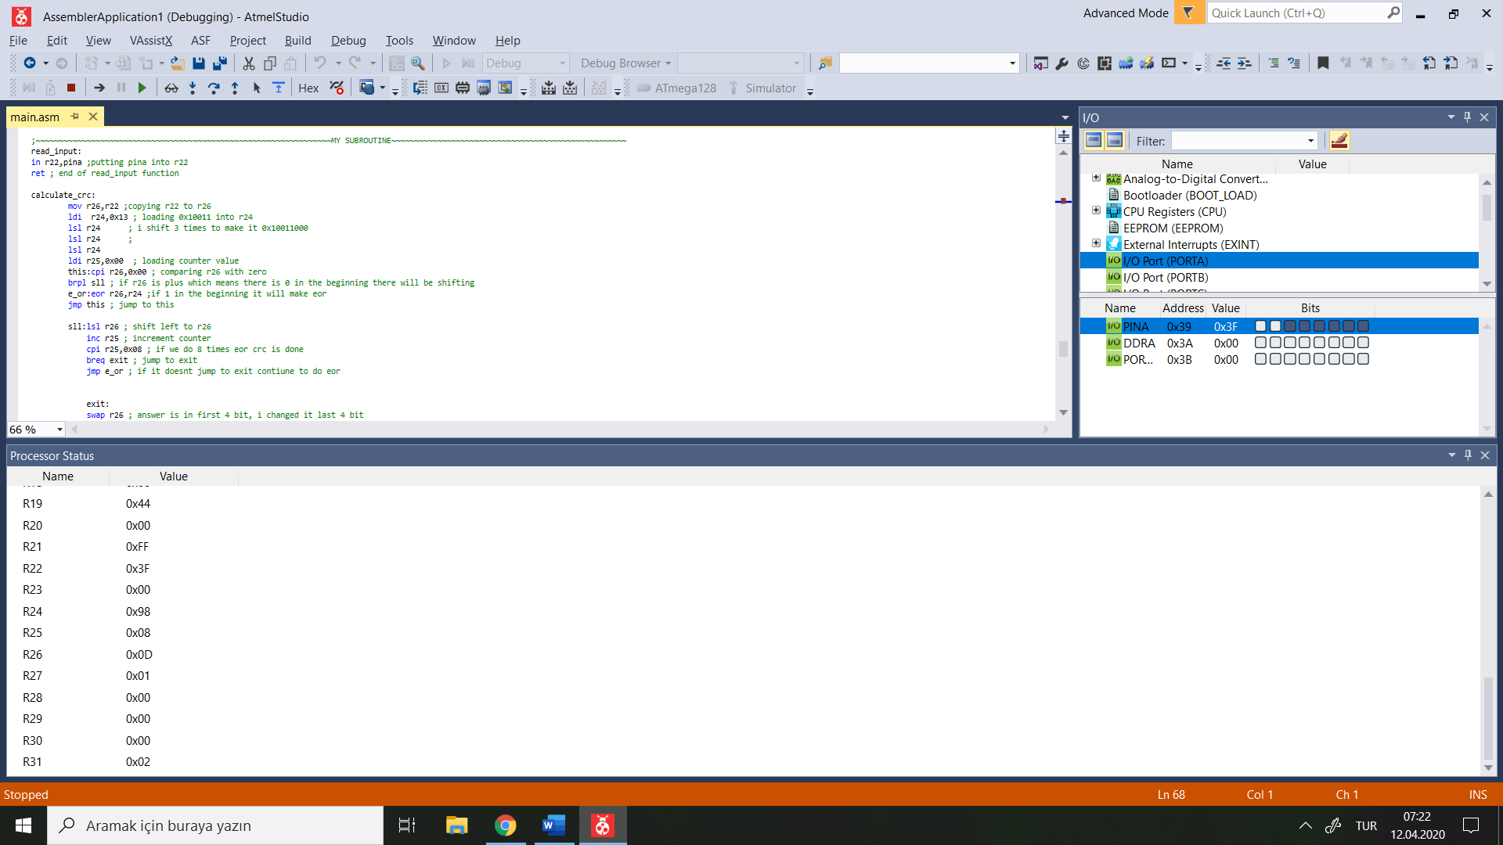

It is 0x0D as above.

Value at Stack Pointer in Main Subroutine is 0x10FF as follows:

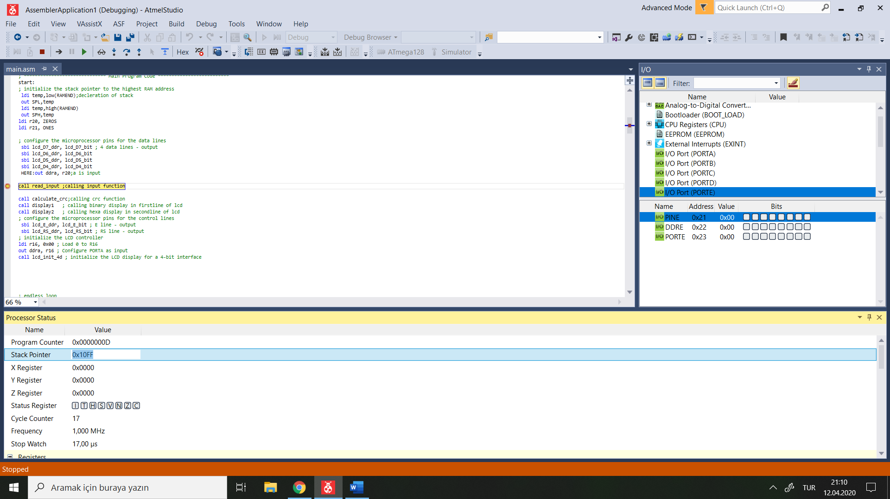

Value at Stack Pointer when read_input subroutine called is 0x10FD 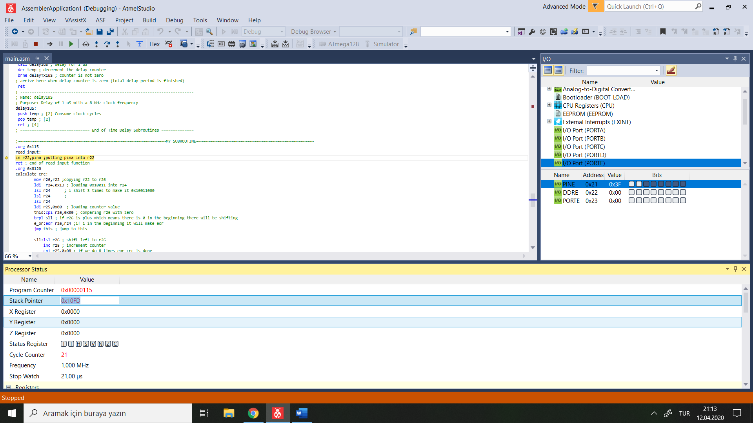

Value at Stack Pointer when calculate_crc subroutine called is 0x10FD

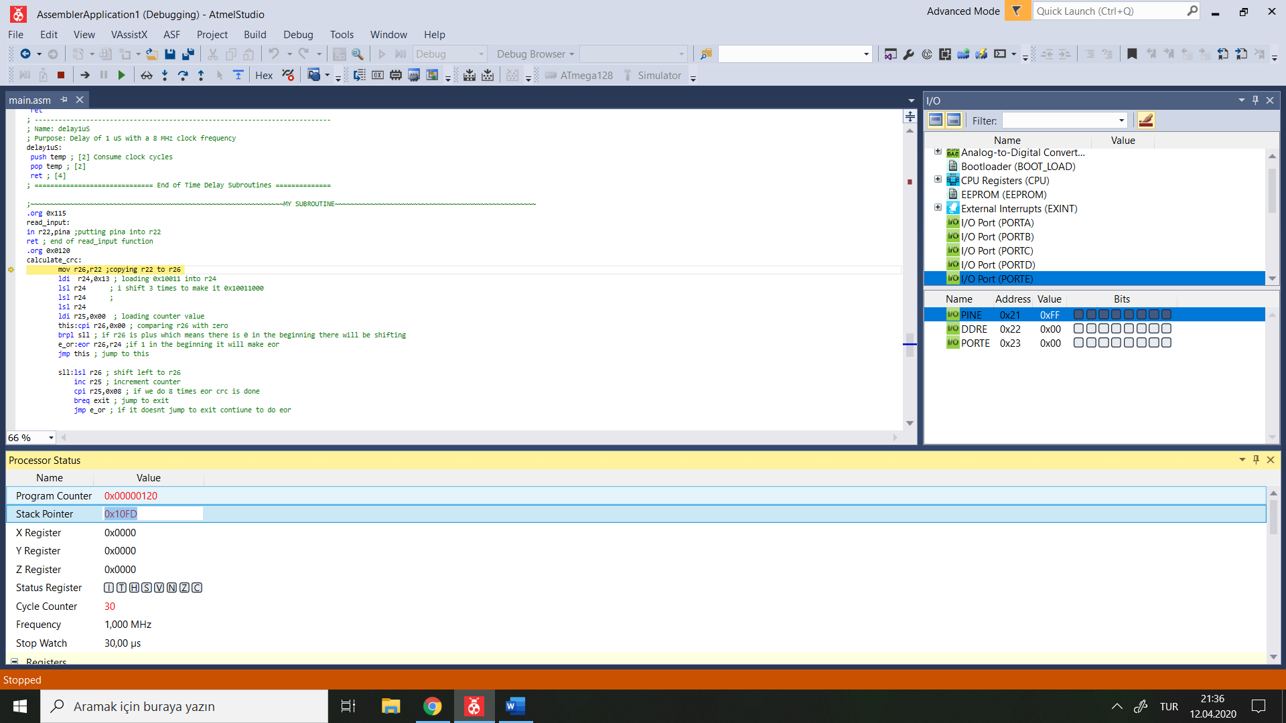

Value at Stack Poiner when display1 subroutine called is 0x10FD

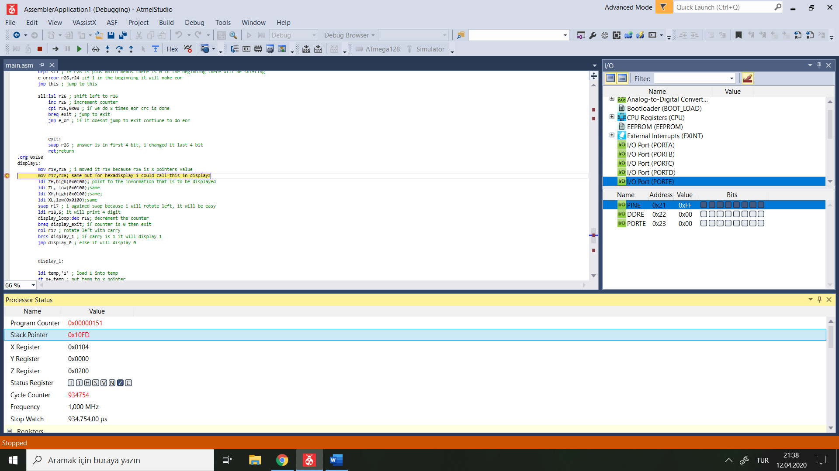

Value at Stack Pointer when display2 subroutine called is 0x10FD

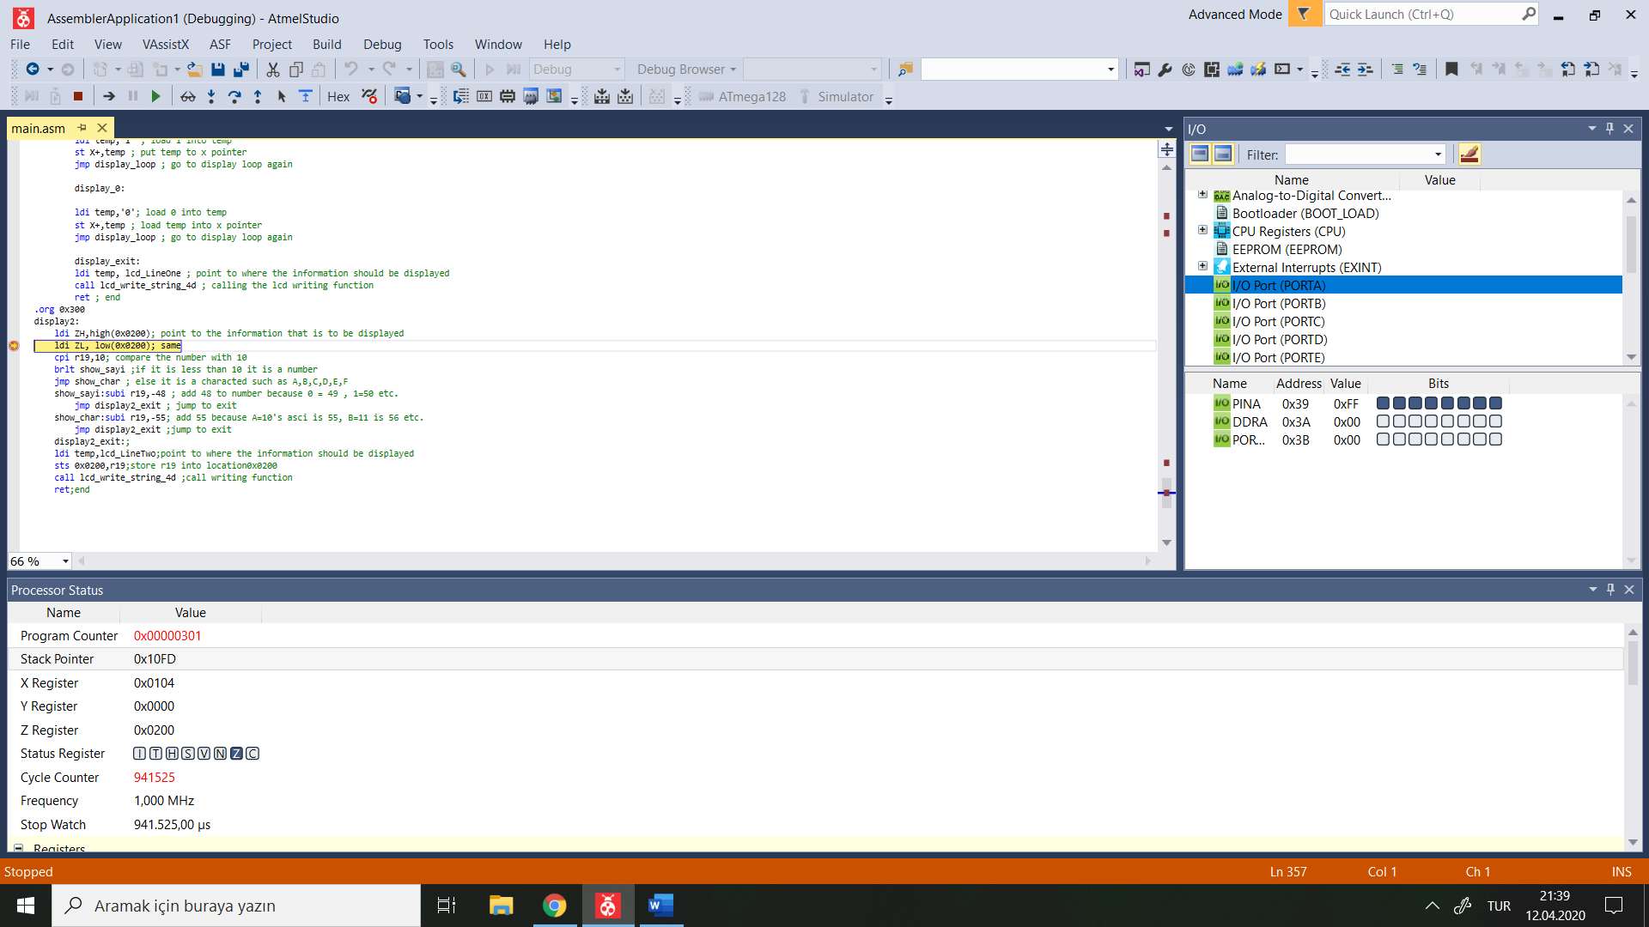

Proteus)

When i enter 0xFF from PINA ,

LCD result should be 0100 which is 4 in hexadecimal.

